
RESEARCH ARTICLE

Glucose Tolerance Test (GTT) Curves of Water and Ethanol

Extracts of Whole Body Apis mellifera jemenitica
[version 1; peer review: awaiting peer review]
Raaih Marwae Ahmad Asseri1, Mohamed Adam Ali Ismail1, Hamed A Ghramh2,3, Wed Mohammed Ali Alarjani4, Tarik El-Sayed Ali Ismail5, Mogbel A A El-Niweiri2, Mohammed Mohammed 5
1Department of Chemical Engineering, King Khalid University, Abha, Aseer Province, Saudi Arabia
2Department of Biology, King Khalid University, Abha, Aseer Province, Saudi Arabia
3Honeybees and their Products Research Center, King Khalid University, Abha, Aseer Province, Saudi Arabia 4Department of Chemistry- Preparatory Year Program, Batterjee Medical College, Abha, Aseer Region, Saudi Arabia 5Department of Chemistry, King Khalid University, Abha, Aseer Province, Saudi Arabia

v1 First published: 04 Sep 2025, 14:872 https://doi.org/10.12688/f1000research.166622.1
Latest published: 04 Sep 2025, 14:872 https://doi.org/10.12688/f1000research.166622.1
Open Peer Review
Approval Status AWAITING PEER REVIEW
Any reports and responses or comments on the article can be found at the end of the article.

Abstract Background
This article explored the chemical constituents of water and ethanol extracts from the whole body of Apis mellifera jemenitica (A. m. jemenitica) honeybee drones and workers, investigating their effects on glucose tolerance test (GTT) curves through feeding experiments conducted on Oryctolagus cuniculus male rabbits.
Methods

Chemical analysis of the extracts was performed using infrared (IR) spectroscopy alongside the spectral database of organic compounds.
Results
The water extract revealed a richer diversity of natural products (38 compounds) compared to the ethanol extract (12 compounds).
Notably, the water extract comprised various bioactive molecules, including sugars and their derivatives, phenolic compounds, alkaloids, quinones, amino acid derivatives, dipeptides, and organometallic compounds. In contrast, the ethanol extract primarily contained sugar derivatives, phenolic compounds, alkaloids, and pesticides. The water extract decreased the blood glucose level and transformed the GTT curve from a convex to a concave shape.

Conclusion
The blood glucose-lowering effect of the water extract may be attributed to the anti-diabetic properties of its dipeptides, phenolic compounds and alkaloid contents.

Keywords
Chemical composition of honeybees, biological activity, IR spectrometry, spectral database of organic compounds, biochemistry and chemical ecology, hive product science

Corresponding author: Mohammed Mohammed (mohammedelimam@yahoo.com)
Author roles: Asseri RMA: Investigation, Methodology, Writing – Original Draft Preparation; Ismail MAA: Conceptualization, Supervision, Writing – Original Draft Preparation, Writing – Review & Editing; Ghramh HA: Funding Acquisition, Resources, Writing – Original Draft Preparation, Writing – Review & Editing; Alarjani WMA: Formal Analysis, Methodology, Resources, Writing – Original Draft Preparation, Writing – Review & Editing; Ismail TESA: Formal Analysis, Methodology, Resources, Validation, Writing – Review & Editing; El-Niweiri MAA: Conceptualization, Formal Analysis, Validation, Writing – Original Draft Preparation, Writing – Review & Editing; Mohammed M: Conceptualization, Formal Analysis, Funding Acquisition, Methodology, Project Administration, Resources, Software, Supervision, Validation, Writing – Original Draft Preparation, Writing – Review & Editing
Competing interests: No competing interests were disclosed.
Grant information: The authors extend their appreciation to the Deanship of Scientific Research at King Khalid University for funding this work through Big groups project under grant number (66/46). Moreover, this research was logistically supported by the Saudi Aramco.
The funders had no role in study design, data collection and analysis, decision to publish, or preparation of the manuscript.
Copyright: © 2025 Asseri RMA et al. This is an open access article distributed under the terms of the Creative Commons Attribution License, which permits unrestricted use, distribution, and reproduction in any medium, provided the original work is properly cited.
How to cite this article: Asseri RMA, Ismail MAA, Ghramh HA et al. Glucose Tolerance Test (GTT) Curves of Water and Ethanol Extracts of Whole Body Apis mellifera jemenitica [version 1; peer review: awaiting peer review] F1000Research 2025, 14:872 https://doi.org/10.12688/f1000research.166622.1
First published: 04 Sep 2025, 14:872 https://doi.org/10.12688/f1000research.166622.1

- Introduction
Entomotherapy refers to the use of insects and their products for the treatment of various diseases. Insects are known to possess bodies and products that are rich in bioactive compounds, enabling them to act as antimicrobial, antioxidant, anticancer, and immunomodulatory agents (Guarnieri et al., 2022; Khayrova et al., 2022; Seabrooks & Hu, 2017). This practice is prevalent in several cultures, notably in countries such as China, India, Thailand, and parts of Africa. Traditionally, insects have been used to treat a variety of ailments, including kidney diseases, digestive tract disorders, asthma, chronic cough, liver issues, rheumatoid conditions, and tooth pain (Siddiqui et al., 2023).

Honeybee larvae and pupae have been reported to be effective in treating skin wounds, gastrointestinal issues, and mental health distress (Meda et al., 2004). According to Choi (2021), extracts from the pupae of Apis mellifera ligustica (A. m. ligustica) drones demonstrated a range of biological activities, including antimicrobial, antioxidant, anti-inflammatory, anti- diabetic, anti-obesity benefits, skin whitening effects, prevention of hair loss, and an increase in blood testosterone levels (Choi, 2021). Both the brood (larvae and pupae) and adult honeybees are known to contain various bioactive and nutritious compounds, such as proteins, essential amino acids, saturated and monounsaturated fatty acids, vitamins, minerals, and antioxidants. The nutritional composition of Apis mellifera larvae and pupae is influenced by factors including their diet, health, age, species, climatic conditions, and seasonal variations (Guiné et al., 2022; Ghosh et al., 2016). However, it’s also important to note that the whole body of Apis mellifera can contain environmental contaminants like pesticides, heavy metals, and veterinary drugs, which could impact their safety and efficacy (Traynor et al., 2021; Savarino et al., 2020; Borkovcová et al., 2022).

The Glucose Tolerance Test (GTT) is a diagnostic procedure designed to assess a patient’s ability to metabolize glucose effectively. It plays a crucial role in identifying conditions such as diabetes mellitus, insulin resistance, acromegaly (reactive hypoglycemia), and disturbances in carbohydrate metabolism, as well as evaluating pancreatic beta-cell function (Eyth et al., 2024).

The Oral Glucose Tolerance Test (OGTT) consists of several key steps: 1) Fasting Preparation: The patient must arrive at the laboratory in a fasting state, ideally in the morning; 2) Initial Blood Sample: A baseline blood sample is collected to measure the fasting blood glucose level; 3) Glucose Administration: The patient is given an oral glucose load, typically 70 grams dissolved in 250 mL of water or 1.75 grams per kilogram of body weight for children; and 4) Subsequent Blood Sampling: Blood samples are taken every 30 minutes for a duration of two to three hours to monitor changes in blood glucose levels. It is essential to collect blood samples in fluoride-containing tubes to prevent a decrease in glucose concentration. The fluoride acts as an inhibitor of glycolysis by blocking aldolase, thereby preserving the glucose levels for accurate measurement (Eyth et al., 2024).

This article aimed to: 1) investigate the chemical constituents of water and ethanol extracts of adult A. m. jemenitica honeybees to assess their potential medicinal values; 2) explore the effects of these extracts on GTT curves and blood glucose levels using Oryctolagus cuniculus rabbits as experimental subjects; and 3) identify which specific chemical constituents of the extracts may account for their effects on the GTT curve. To our knowledge, this study is unique as it is the first to examine the bioactive compounds, in addition to nutritive biomolecules, in the whole bodies of A. m. jemenitica workers and drones.

- Material and methods
  - Ethical clearance and informed consent This research was carried out after being approved by the research ethics committee of King Khalid University under the license number (ECM#2024-2004). The issued ethical license is entitled as Effectiveness of Extracts of sugar ants and A. m. jemenitica in the treatment of diabetes mellitus. The Oryctolagus cuniculus rabbits were used as animal models for the treatment of diabetes mellitus. However, the Oryctolagus cuniculus rabbits are not mentioned in title of the ethical license, but it was stated in the proposal sent to the ethical committee. Regarding the informed consent, we are the owners of the honeybees and the rabbits. The honeybees were obtained from our apiaries and the rabbits were bought from the local market private veterinary clinics.

  - Research design and the study groups
This study followed a pilot true experimental research design. It included a control group (four rabbits) and two experimental groups (two rabbits each). Initially, all four rabbits served as the control group before being divided into two experimental groups of two rabbits each. The four rabbits were from the species of Oryctolagus cuniculus rabbits.

  - Preparation of the honeybee samples extraction in water and ethanol
The study sample consisted of adult workers and drones of A. m. jemenitica. To collect bee samples from a hive, specific steps were followed: 1) Smoke was utilized to calm the bees and reduce aggression; 2) The hive was opened gently, ensuring that the queen was absent; 3) A frame was removed from the hive and examined to confirm the absence of the queen; 4) The frame was placed next to a sample collection box; and 5) The bees were gently shaken into the box and quickly closed to prevent them from flying away. The gentle shaking aimed to minimize the level of monoamine neurotransmitters (dopamine, octopamine, and serotonin) in the hemolymph to prepare the honeybees for euthanasia. Euthanasia of the studied honeybees was achieved by transferring them into liquid nitrogen, ensuring rapid death due to the extremely low temperature, similar to using dry ice for killing honeybees (Mutinelli, 2021).

The deceased honeybees were divided into two parts (10 g each) and soaked in water and ethanol. The soaked honeybee samples were then incubated for 48 hours at 35°C while shaking to facilitate effective extraction (Mutinelli, 2021).

  - The experimental Oryctolagus cuniculus rabbits and the blood sampling The four Oryctolagus cuniculus rabbits were housed in pairs (two rabbits per cage) for a one-week acclimatization period. Following adaptation, all rabbits received an oral glucose (MERCK; G8270-1KG) load to establish baseline GTT curves, which served as control data. After a one-week washout period, the rabbits were divided into two experimental groups (n=2 per group) to assess the effects of aqueous and ethanolic honeybee extracts on GTT profiles.

    - Inclusion and exclusion criteria

Only physically healthy, 3 month age and male Oryctolagus cuniculus rabbits were included in this study.

    - Blinding

Asseri RM and Mohammed MEA were responsible for looking after the rabits and blood sampling. All the rabbits were put in the same conditions in one animal house at room temperature.

  - Blood sampling and measurement of blood glucose
Blood samples were collected from the central ear artery after applying a local anesthetic and disinfecting the area with 70% ethanol. A few drops of blood were placed directly onto a Contour TS glucometer (Bayer HealthCare, Germany) and the glucose concentration (mg/100 mL) was recorded.

  - The Glucose Tolerance Test (GTT) procedure
Four key steps were implemented to conduct GTT: 1) Overnight Fasting: Rabbits were subjected to fasting overnight to establish a baseline; 2) Fasting Blood Sample: A fasting blood glucose sample was collected following the fasting period; 3) Glucose Administration: Each rabbit was given a glucose load of 1 g/kg orally; and 4) Post-Load Sampling: After the glucose administration, blood samples were taken every 30 minutes for a duration of three hours to monitor glucose levels (Eyth et al., 2024; Moro & Magnan, 2025).

  - IR spectrometry
The IR scanning was conducted using the Agilent Cary 630 FTIR Spectrometer (Agilent, USA), accompanied by the Agilent MicroLab software suite. A single drop of each extract was placed on the sampler, and the scanning was performed across a spectral range of 7000 to 350 cm^{—1}. The resulting spectra highlighted specific peak values, which were subsequently recorded for analysis.

  - Searching the spectral database for organic compounds (SDBS)
Spectral matching was performed using the spectral database for organic compounds (https://sdbs.db.aist.go.jp/Search- Information.aspx) to identify the probable chemical constituents. Two parameters are set by the database developers to control the quality of the obtained search results: 1) the absorption wavelength matching range (Allowance), expressed as
number (1, 2, etc.); and 2) the transmission percentage. Precise search results are obtained by minimizing both the Allowance and the transmission percentage. The set of IR spectra search criteria depends on the nature of the sample, whether it is crude or pure and the processing method. Low values for the Allowance range and transmission percentage are generally set for pure compounds (SDBS, 2025; Coates, 2006). The SDBS search criteria are presented in a supplementary file (Supplement.1).

The PubChem database (https://pubchem.ncbi.nlm.nih.gov/) was employed to identify the basic chemical information and functions of the identified compounds. Additionally, some of the biological activities of the suggested compounds were gathered by searching the published literature.

  - Statistical analysis
The results of the blood glucose concentration were analyzed using the Statistical Package for Social Sciences (SPSS) version 20. The mean values of the blood glucose concentration of the different study groups were compared using the Analysis of Variance (ANOVA) test, with significant variation determined at a level of p-value ≤ 0.05.

- Results
To enhance the clarity of this article, the results section is divided into three parts: IR Spectral Analysis, Compound Identification, and GTT Results, highlighting the bioactivity of the water and ethanol extracts.

  - IR Spectral analysis
The analysis of the infrared (IR) spectra provided insight into the chemical composition of the extracts.

In the case of the water extract, two primary IR peaks were identified at 1633.36 cm^{—1} and 3262.34 cm^{—1} [Figure 1]. The peak at 1633.36 cm^{—1} is correlated with C=C stretching or bending vibrations, indicating the presence of carbonyl compounds or conjugated systems, whereas the peak at 3262.34 cm^{—1} indicates hydroxyl groups (-OH), proposing a rich content of phenolic compounds and other alcohols (Coates, 2006).

For the ethanol extracts, a broader range of IR peaks was observed, specifically at 644.32 cm^{—1}, 879.62 cm^{—1}, 1045.25 cm^{—1}, 1087.16 cm^{—1}, 1324.28 cm^{—1}, 1377.27 cm^{—1}, 1459.69 cm^{—1}, 2881.44 cm^{—1}, 2972.69 cm^{—1}, and
3325.92 cm^{—1} [Figure 2]. These peaks provide details about various functional groups present in the ethanol extracts. Notably, the peaks around 1045.25 cm^{—1} and 1087.16 cm^{—1} are characteristic of C–O stretching vibrations, often associated with sugar derivatives and alcohols. Additionally, the peaks at 2881.44 cm^{—1} and 2972.69 cm^{—1} relate to C–H stretching, suggesting the presence of aliphatic hydrocarbons, while the peak at 3325.92 cm^{—1} indicates the presence of hydroxyl groups (Coates, 2006).

This comparative analysis highlights the differences in the chemical profiles of the water and ethanol extracts, which may contribute to their varying biological activities as observed in the glucose tolerance test.

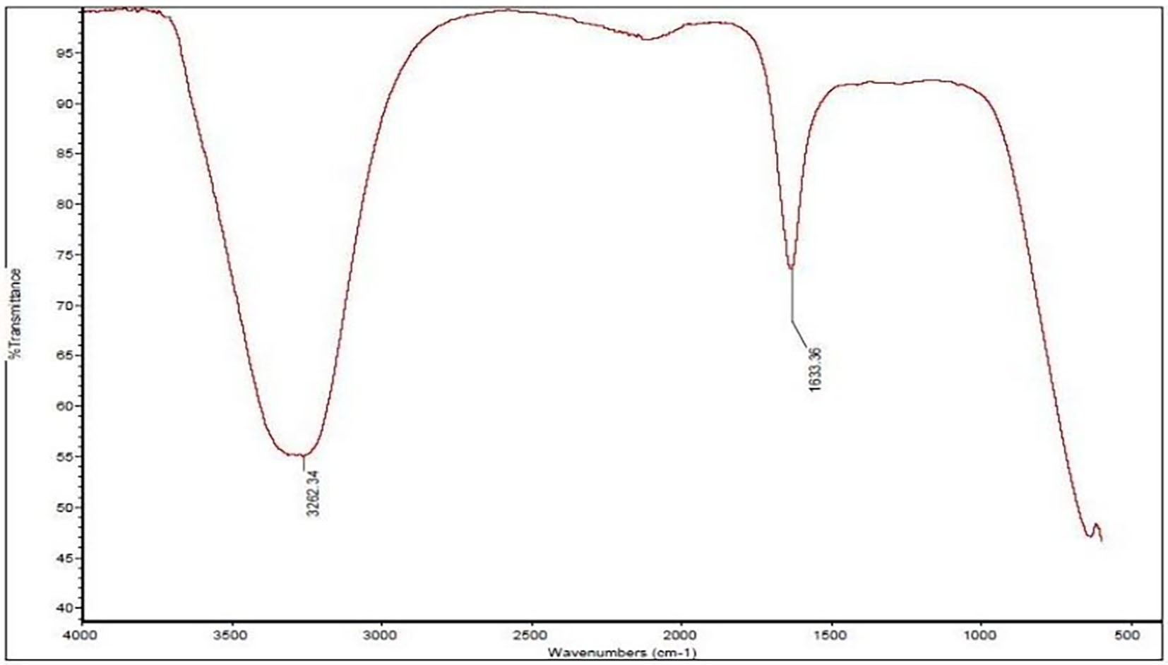

Figure 1. Shows the IR spectrum of the water extract, highlighting two distinct peaks.

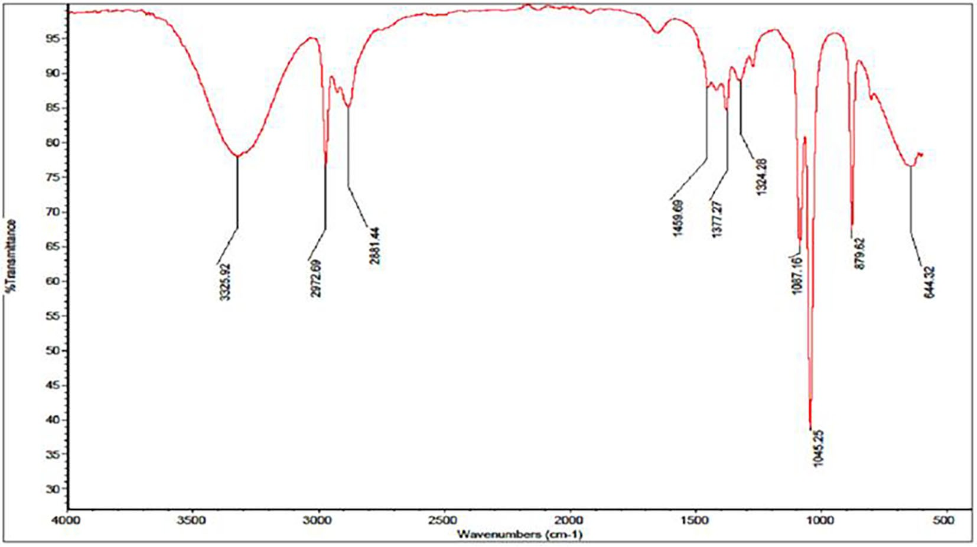

Figure 2. Displays the IR spectrum of the ethanol extract emphasizing 10 noticeable peaks.

  - Compound identification
As previously mentioned, the identification of the corresponding compounds for the IR peaks was accomplished by searching the spectral database of organic compounds (SDBS). The chemical structures and their functions were further elucidated using the PubChem database and relevant literature.

In the case of the water extract, the two IR peaks identified were found to correspond to a total of 39 compounds within the SDBS. A comprehensive list of these compounds is provided in (Table 1-Table 7) (Supplement 2).

For the ethanol extract, the spectral analysis revealed that its IR peaks corresponded to 12 compounds, as detailed in (Table 1-Table 7) (Supplement 3).

The compounds identified in both extracts were categorized into various groups based on their chemical nature and biological potential. The classifications include: sugars and sugar derivatives (Table 1), phenolic compounds (Table 2), alkaloids (Table 3), quinones (Table 4), dipeptides (Table 5), amino acid derivatives (Table 6) and organometallic compounds and pesticides (Table 7).

This classification not only aids in understanding the chemical complexity of the extracts but also provides insight into their potential biological activities, which may be relevant for their applications in medicinal and therapeutic contexts.

  - GTT results
    - Patterns of GTT curves

The GTT curve for glucose alone exhibited two distinct phases: an initial increase followed by a decrease. In contrast, the GTT curve for glucose mixed with the water extract demonstrated a decrease initially followed by an increase. The GTT curve involving glucose mixed with the ethanol extract was more complex, displaying three phases: a slight increase, a slight decrease, and then a subsequent increase [Figure 3]. These variations in the GTT curves can likely be attributed to the different constituents present in the water and ethanol extracts of the A. m. jemenitica drones and workers.

    - Comparison of the blood glucose results

The glucose concentration in the blood samples was measured from the rabbits at two distinct time points: at zero time (fasting) and after breaking the fast at intervals of 90, 120, 150, and 180 minutes. Blood samples were collected from three different groups involved in the GTT: a control group that received glucose alone, a group that

Table 1. The sugars and their derivatives in the water and ethanol extract of the workers and drones of Apis mellifera jemenitica.
F1000Research 2025, 14:872 Last updated: 22 OCT 2025
Page 7 of 30

 | Class | Compound and formula | Chemical structure | Biological activity | Extract | Pubchem ID
1 | Sugars | 6-deoxy-beta-L-galactopyranose | 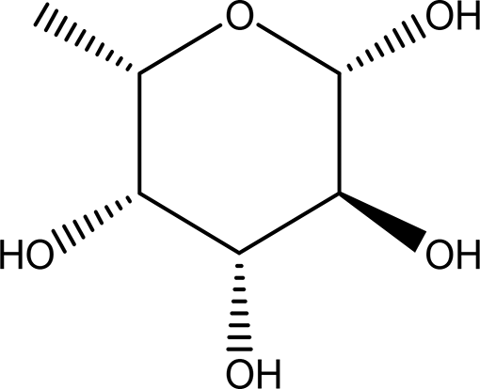 | Antitumor | Water | Pubchem:
 | and their | (L-Fucose) |  | Anti-aging | and | 444863
 | derivatives | C6H12O5 |  | Relief of intestinal disease | ethanol | SDBS:32641
 |  | C6H12O5 |  | Component in skin care products
 |  |  |  | Emulsifier in food industry (Wang et al., 2024;
 |  |  |  | Adhikari et al., 2022; Garber et al., 2021; Al-
 |  |  |  | Baarri et al., 2018; 21. Fiume et al., 2019).
 |  | 6- deoxy-D- galactose (D- Fucose) C6H12O5 | 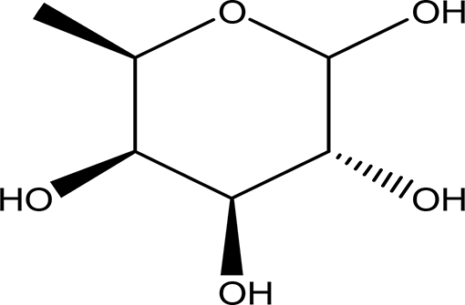 | Anti- human acrosin which causes male infertility (National Center for Biotechnology Information, 2024a; Klemm et al., 1991). | Ethanol | Pubchem: 444200 SDBS:2561
 |  | (S)-1,2-O-(2,2,2- | 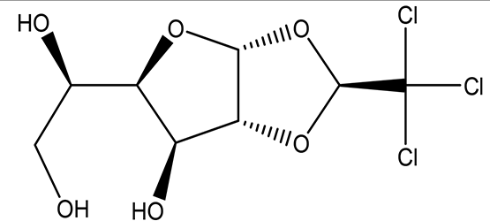 | Sedative | Ethanol | Pubchem:
 |  | trichloroethylidene)-alpha-D- |  | Anesthetic in animal experiments |  | 5284343
 |  | glucofuranose C8H11Cl3O6 |  | Induction of drowsiness and sleep (National Center for Biotechnology Information, 2024b). |  | SDBS:15171
 |  | methyl 2,3,4-tri-O- | 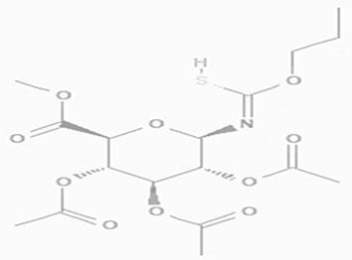 | May increase bone matrix deposition | Ethanol | Pubchem:
 |  | acetyl-1-deoxy-1-(propoxy |  | (Nagaoka et al., 2012). |  | 273075659
 |  | (thiocarbonyl))amino-beta- |  |  |  | SDBS:32735
 |  | D-glucopyranuronate
 |  | C17H25NO10S
The only compound which is reported in both the water and ethanol extracts is the L- fucose.

Table 2. The phenolic compounds in the water and ethanol extract of the workers and drones of Apis mellifera jemenitica.
F1000Research 2025, 14:872 Last updated: 22 OCT 2025
Page 8 of 30

 | Class | Compound | Chemical structure | Biological activity | Extract | ID
2 | Phenolic compounds | 2,4,6-trimethylpyridinium p-toleunesulfonate C15H19NO3S | 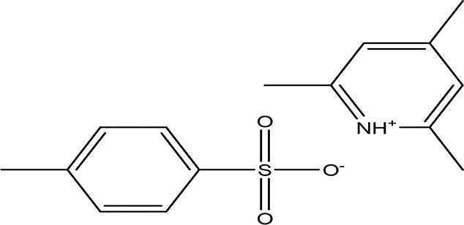 | It is used for chemical synthesis (Chemical book, 2023). | Water | Pubchem: NA SDBS:18269
2 | Phenolic compounds | 2,4- dihydroxybenzoic acid C7H6O4 | 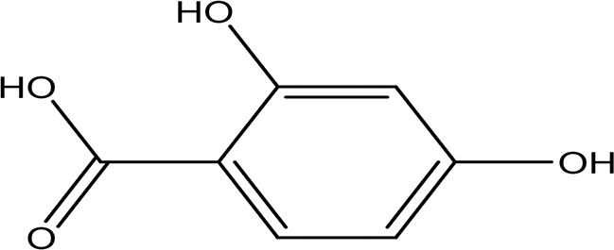 | Plays a role in plant immunity Antioxidant and antimicrobial (Lu et al., 2024; Kalinowska et al., 2021). | Water | Pubchem: 1491 SDBS:3084
2 | Phenolic compounds | 2,3-naphthalenediol C10H8O2 | 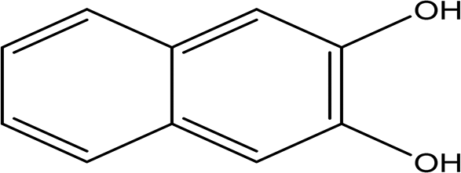 | Antioxidant, antiplatelet aggregation, anti-inflammatory, antimicrobial and anti-protozoa (Ibrahim and Mohamed, 2016). | Water | Pubchem: 7091 SDBS:1626
2 | Phenolic compounds | 6-methyl-2-benzothiazolamine C₈H₈N₂S | 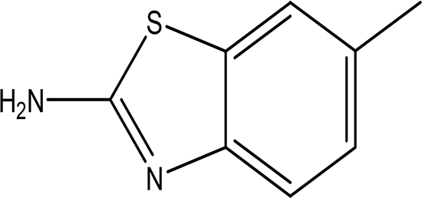 | Anti-tubercular, antimicrobial, anti- inflammatory, anti-convulsion, anti- diabetic and anticancer (Ali and Siddiqui, 2013; Dhadda et al., 2021). | Water | Pubchem: 17335 SDBS: 3579
2 | Phenolic compounds | 3-amino-4- hydroxybenzenesulfonic acid C₆H₇NO₄S | 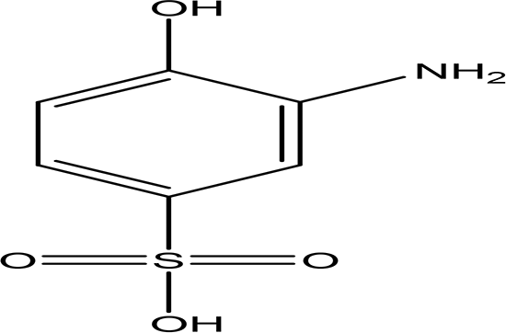 | Anti- acute myeloid leukemia inhibitor of some enzymes antagonist and agonist of some pathways (National Center for Biotechnology Information, 2024f). | Water | Pubchem: 7385  SDBS: 10121

F1000Research 2025, 14:872 Last updated: 22 OCT 2025
Page 9 of 30

Table 2. Continued
 | Class | Compound | Chemical structure | Biological activity | Extract | ID
 |  | 5-(p-aminophenyl)-2- thiazolamine C₉H₉N₃S | 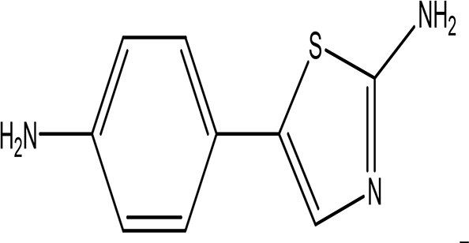 | Collectively, the amino phenol and the thiazoleamine have antimicrobial and anti-diabetic activities (Rafique et al., 2022; Ali and Sayed, 2021). | Water | Pubchem: 605642 SDBS:32115
 |  | 3'-hydroxy-2'-acetonaphthone C12H10O2 | 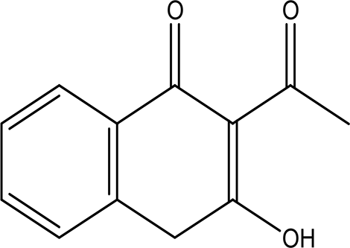 | It may act as antimicrobial and anti- convulsion (Karakurt et al., 2010; National Center for Advancing Translational Sciences, 2020). | Water | Pubchem: NA SDBS: 28941
 |  | 4-nitro-2-(trifluoromethyl)aniline C7H5F3N2O2 | 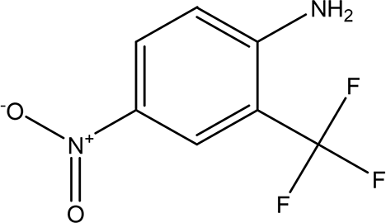 | It is used for the synthesis of monoazo dyes (Dickey et al., 1953). Anti-tuberculosis, antiviral, anticancer and antidepressant (Nair et al., 2022). | Water | Pubchem: 67128 SDBS:3261
 |  | 5,6-dihydro-4H-benzo(6,7) cyclohepta(1,2-d)thiazol-2-amine hydrobromide  C₁₂H₁₂N₂S HBr | NA | Anti-angiogenesis (Bhat et al., 2013). | Water | Pubchem: NA SDBS:26013
 |  | O-  (N-(dimethylcarbamoylmethyl) acetamido)-N-N- dimethylbenzamide C15H21N3O3 | 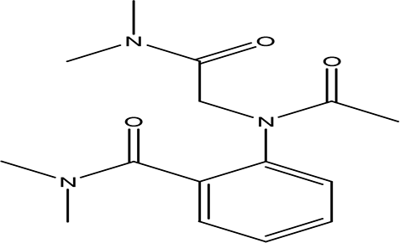 | Anticancer, Anti-epilepsy, antiviral, anti-Alzheimer and urease inhibitor (Ghosh and Brindisi, 2019; Matošević and Bosak, 2020; Ahmad et al., 2023a). | Water | Pubchem: 600891 SDBS:32336

F1000Research 2025, 14:872 Last updated: 22 OCT 2025
Page 10 of 30

Table 2. Continued
 | Class | Compound | Chemical structure | Biological activity | Extract | ID
 |  | 8-cyano-3,3-diphenyl-3,3a- dihydrocyclohepta(b)furan-2- one  C22H15NO2 | 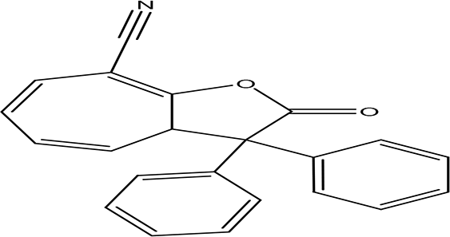 | Anti-tumor, antimicrobial, antioxidant and anti-inflammatory (Miao et al., 2019). | Water | Pubchem: 275779763 SDBS:30670
 |  | 2-ethylthio (thiocarbonyl)amino- phenylpropionic acid cyclohexylamine salt C12H15NO2S2 C6H13N | 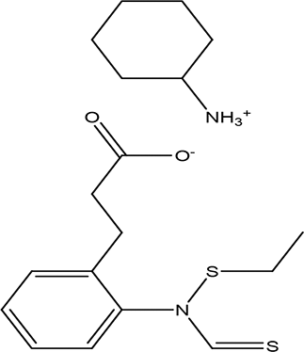 | Phenylprpoanoid derivatives Antimicrobial, antioxidant, anti- inflammatory, antidiabetic and anticancer (Neelam et al., 2020). Cyclohexylamine derivatives Analgesic activity and decrease the the motor activity (Glushkov et al., 2006). | Water | Pubchem: NA SDBS:29929
 |  | Tiropramide hydrochloride C₂₈H₄₁N₃O₃ HCl | 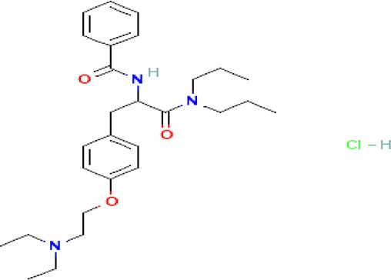 | Antispasmodic for hepatobiliary and urinary tract diseases (National Center for Biotechnology Information, 2024h, Lee et al., 2013; Center for Advancing Translational Sciences, 2024). | Water | Pubchem: 134448  SDBS: 53486
 |  | 2-methyl-1,2,3,4- tetrahydro-2-naphthol C11H14O | 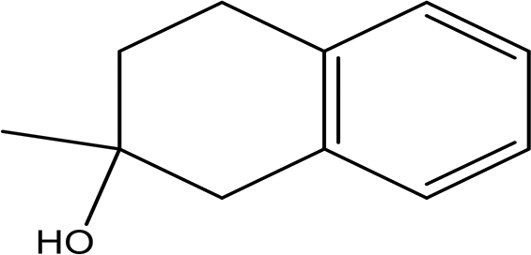 | Antioxidant and inhibitor of acetylcholinesterase (Erdoğan et al., 2021). | Ethanol | Pubchem: NA SDBS: 31692

Table 2. Continued
 | Class | Compound | Chemical structure | Biological activity | Extract | ID
 |  | (4aalpha, 7alpha, 9alpha, 9aalpha)-9-9a-epoxy-1,1,41,7-  tetramethyl-2,3,4,4a,5,6,7,8,9,9a- decahydro-  1H-benzocyclohepten-7-ol C15H26O2 | NA | As a benzocycloheptane derivative it can act as antihistamine and anti- hepatoma (Abounassif et al., 2005; Liang et al., 2020). | Ethanol | Pubchem: NA SDBS: 32776
 |  | ethyl p-((2-chloroethoxy) carbonylamino) benzoate C₁₂H₁₄CINO₄ | 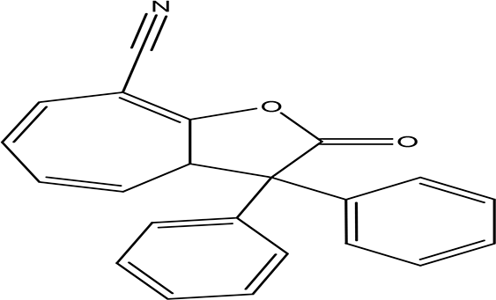 | benzoate derivatives have antioxidant, anticancer, antimicrobial, anti-Alzheimer and they are used as pesticides Zou et al., 2019; Haroon et al., 2023; Lee et al., 2023; Elabasy et al., 2019). | Ethanol | Pubchem: 273078333  SDBS: 33657
 |  | Lasalocid Sodium Salt C34H53NaO8 | 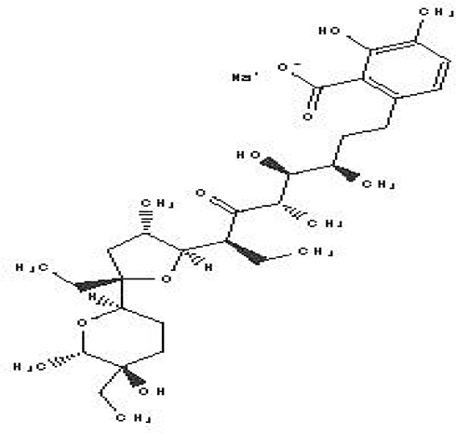 | Veterinary antimicrobial and ionophore (National Center for Biotechnology Information, 2024i). | Ethanol | Pubchem: 6426773  SDBS: 21356
 |  | methyl 4-(3,5-  dichloro-4-methoxyphenyl)-3- ethyl-1-pyrazoline-3-carboxylate C14H16Cl2N2O3 | 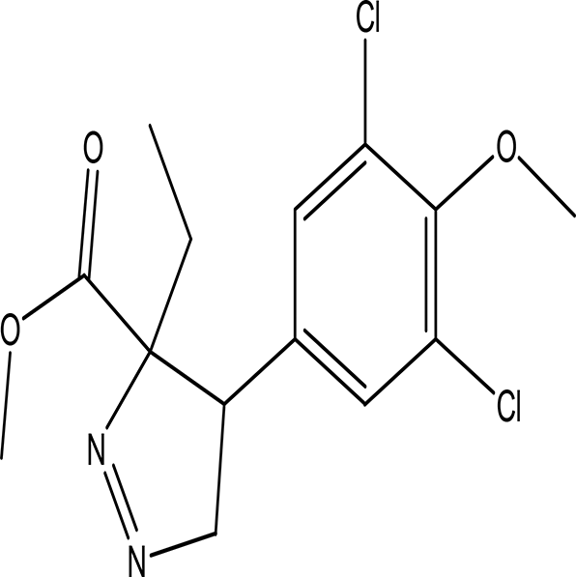 | Methoxyphenyl dervitives act as anti food spoilage bacteria and antioxidant (Orlo et al., 2021; Ahmad et al., 2023b). Pyrazole derivatives exhibit a wide range of pharmacological activities including anticancer, antimicrobial, antioxidant, anti-obesity and antihypertension (Karrouchi et al., 2018; Hassan, 2013). | Ethanol | Pubchem: 274969331  SDBS: 39016
F1000Research 2025, 14:872 Last updated: 22 OCT 2025
Page 11 of 30

Table 2. Continued
 | Class | Compound | Chemical structure | Biological activity | Extract | ID
 |  | 2',7'-dihydroxyspiro (isobenzofuran-1(3H),9'-(9H) xanthen)-3-one  C20H12O5 | 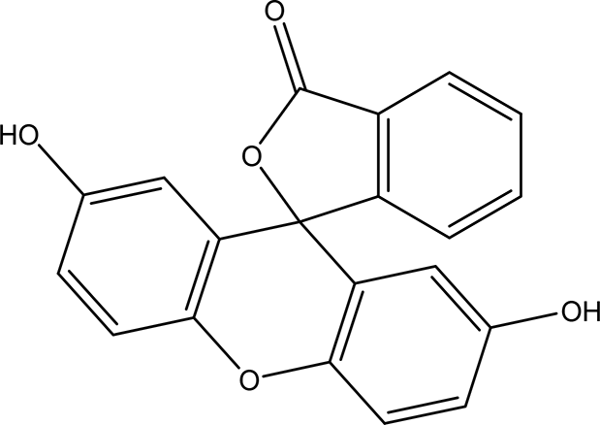 | Antitumor, antibacterial, antiviral and antioxidant (Miao et al., 2019). Anticancer, anti-proliferative (Zukić et al., 2020). | Ethanol | Pubchem: 625532  SDBS: 35197
The phenolic compounds are the dominant natural products in the water and ethanol extracts of whole body extracts of Apis mellifera jementica. The hypoglycemic activity of the water extract may be due to its content of phenolic compounds.
F1000Research 2025, 14:872 Last updated: 22 OCT 2025
Page 12 of 30

F1000Research 2025, 14:872 Last updated: 22 OCT 2025
Page 13 of 30

Table 3. The alkaloids in the water and ethanol extract of the drones and workers of Apis mellifera jemenitica.

 | Class | Compound | Chemical structure | Biological activity | Extract | Pubchem ID
3 | Alkaloids | 2-(5-methyl-3-pyrroly) piperidine | 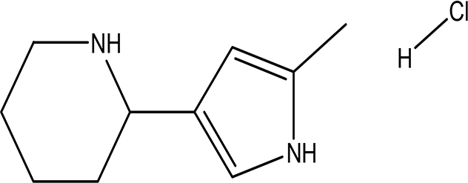 | Anticancer, antimicrobial, anti- | Water | Pubchem: NA
 |  | hydrochloride |  | Alzheimer, antioxidant, anti- |  | SDBS: 37497
 |  | C₁₀H₁₆N₂ HCl |  | neuropathic pain, anti-
 |  | C₁₀H₁₆N₂ HCl |  | hypertension, anti-asthma, anti-
 |  |  |  | inflammation (Frolov and
 |  |  |  | Vereshchagin, 2023; Abdelshaheed
 |  |  |  | et al., 2021).
 |  | 3-methyl-4-oxo-3,4-dihydro-1- | 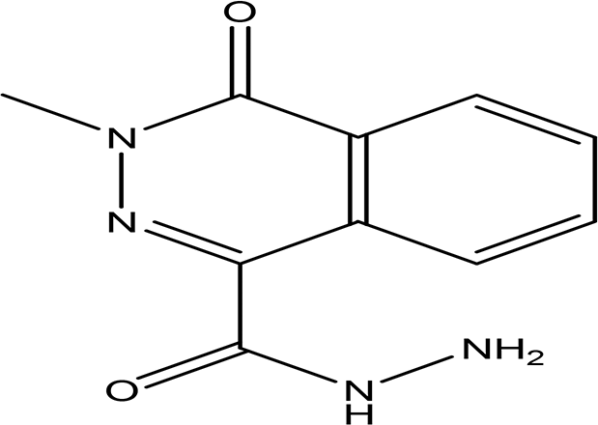 | Phthalazine derivatives | Water | Pubchem:
 |  | phthalazinecarbohydrazide |  | Anticancer, anti-diabetes, anti- |  | 604579
 |  | C10H10N4O2 |  | hypertension, anti-microbes, anti- |  | SDBS: 26308
 |  | C10H10N4O2 |  | depression and they have
 |  |  |  | analgesic activity (Sangshetti et al.,
 |  |  |  | 2019).
 |  |  |  | Carbohydrazide derivatives
 |  |  |  | Antibacterial, antifungal, anti-
 |  |  |  | inflammatory and anti-
 |  |  |  | tuberculosis (Onyeyilim et al.,
 |  |  |  | 2022).
 |  | N-(5-chloro-6-oxo-1-phenyl- | 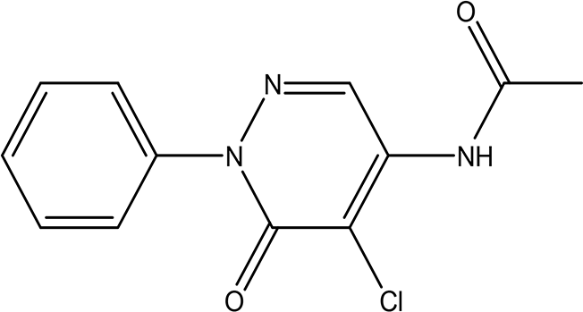 | Pyridazine derivatives | Water | Pubchem:
 |  | 1,6-dihydro- |  | Antitumor, antibacterial and |  | 614997
 |  | 4-pyridazinyl)acetamide |  | antifungal (He et al., 2021; Butnariu |  | SDBS: 34810
 |  | (Alkaloid and phenolic) |  | and Mangalagiu, 2009).
 |  | C12H10ClN3O2 |  | Acetamide derivatives
 |  | C12H10ClN3O2 |  | Antioxidant and anti-inflammatory
 |  |  |  | (Autore et al., 2010).
 |  | 2-hydrazino-3,5,6,7- | 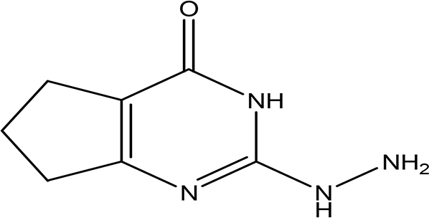 | Hydrazine derivatives | Water | Pubchem:
 |  | tetrahydrocyclopentapyrimidin-4-one |  | Carbonic anhydrase inhibitors Goff |  | 273075486
 |  | C7H10N4O |  | and Ouazzani, 2014; Shirinzadeh |  | SDBS:32423
 |  | C7H10N4O |  | and Dilek, 2020).
 |  |  |  | Cyclopentapyrimidin-4-one
 |  |  |  | derivatives
 |  |  |  | Phosphodiesterase 10A inhibitors
 |  |  |  | (Al-Nema et al., 2022; Bhawale
 |  |  |  | et al., 2023).

F1000Research 2025, 14:872 Last updated: 22 OCT 2025
Page 14 of 30

Table 3. Continued
 | Class | Compound | Chemical structure | Biological activity | Extract | Pubchem ID
 |  | 3'-(9-methyl-9H-pyridazino(3,4-b) | 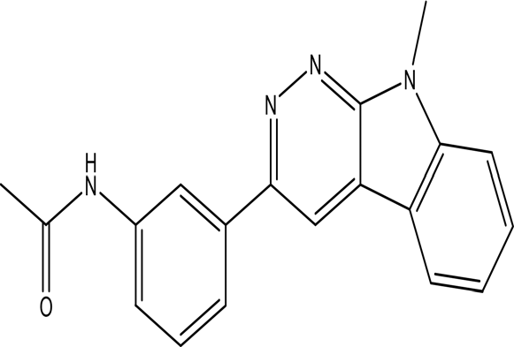 | Pyridazine derivatives | Water | Pubchem:
 |  | indol-3-yl)acetanilide |  | Antitumor, antibacterial and |  | 273078537
 |  | C19H16N4O |  | antifungal (He et al., 2021; Butnariu |  | SDBS:34070
 |  |  |  | and Mangalagiu, 2009).
 |  |  |  | Indole derivatives
 |  |  |  | Antimicrobial, anti-malarial, anti-
 |  |  |  | diabetes, anti-inflammatory and
 |  |  |  | anti-tuberculosis (Kumar and
 |  |  |  | Ritika, 2020).
 |  |  |  | Acetanilide derivatives
 |  |  |  | Analgesic, anti-inflammatory,
 |  |  |  | antipyretic, antioxidant,
 |  |  |  | anticonvulsant, antimicrobial,
 |  |  |  | an-ti-cancer, anti-hyperglycaemia
 |  |  |  | and antimalarial (Singh et al., 2019).
 |  | Cytochalasin E | 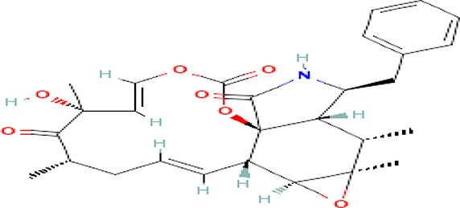 | Inhibitor of angiogenesis and | Water | Pubchem:
 |  | C28H33NO7 |  | increases the sensitivity of lung |  | 5458385
 |  |  |  | cancer to chemotherapy |  | SDBS:13826
 |  |  |  | (National Center for Biotechnology
 |  |  |  | Information, 2024j; Takanezawa
 |  |  |  | et al., 2018).
 |  | 1,4'-bipiperidine | 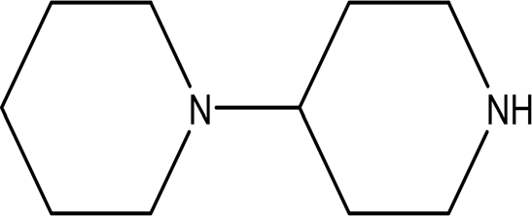 | Anticancer, antimicrobial, anti- | Ethanol | Pubchem: 78607
 |  | C10H20N2 |  | Alzheimer, antioxidant, anti- |  | SDBS:22415
 |  |  |  | neuropathic pain, anti-
 |  |  |  | hypertension, anti-asthma, anti-
 |  |  |  | inflammation (Frolov and
 |  |  |  | Vereshchagin, 2023; Abdelshaheed
 |  |  |  | et al., 2021).
The water extract was rich in alkaloids while only one alkaloid was reported in the ethanol extract. The blood glucose lowering activity may be attributed to its alkaloid content.

F1000Research 2025, 14:872 Last updated: 22 OCT 2025
Page 15 of 30

Table 4. The quinones in the water extract of the drones and workers of Apis mellifera jemenitica.

 | Class | Compound | Chemical structure | Biological activity | Extract | ID
4 | Quinones | 4,5-dianilino-O-benzoquinone C18H14N2O2 | 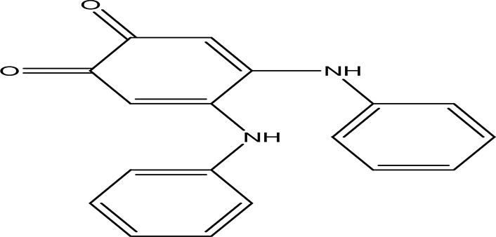 | Antimalarial, anti-Alzheimer, antiviral, antifungal, antibacterial | Water | Pubchem: 274966116
 |  | 4,5-dianilino-O-benzoquinone C18H14N2O2 |  | and antitumor (Huang et al., 1993; Zhang et al., 2021). |  | SDBS:34956
 |  | 1-amino-2-bromo-4- | 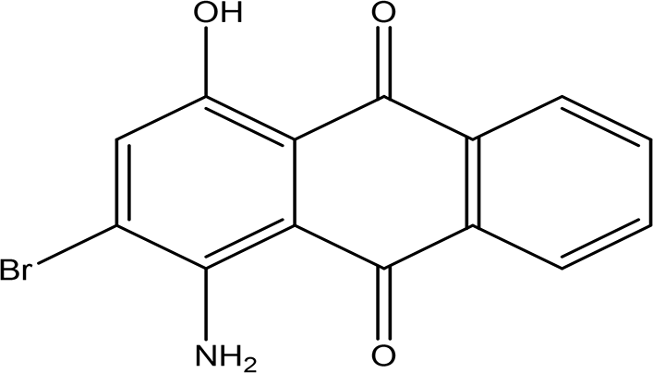 | Antioxidant, anticancer, anti- | Water | Pubchem: 8320
 |  | hydroxyanthraquinone C₁₄H₈BrNO₃ |  | inflammation and anti-aging, hepato-protective and neuro- protective (Zhao and Zheng, 2023). |  | SDBS:18790
 |  | 2,5-bis(2-hydroxypropylamino)- | 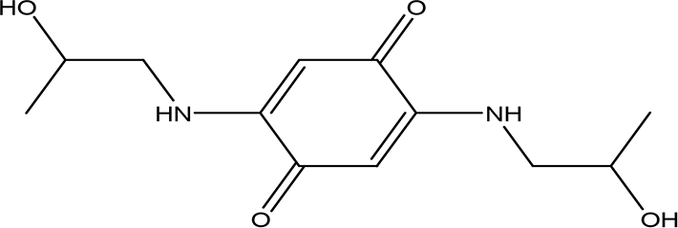 | Antimalarial, anti-Alzheimer, | Water | Pubchem:
 |  | p-benzoquinone |  | antiviral, antifungal, antibacterial |  | 620240
 |  | C12H18N2O4 |  | and antitumor (Zhao and Zheng, 2023). |  | SDBS:25209
 |  | 2,5,6- | 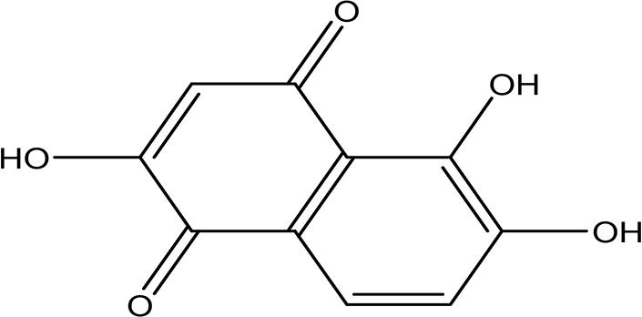 | Anticancer, antibacterial, cytotixic, | Water | Pubchem:
 |  | trihydroxy-1,4-naphthoquinone |  | anti-infammatory and antioxidant |  | 273072755
 |  | C10H6O5 |  | (Nematollahi et al., 2012; Li et al., 2018). |  | SDBS:31333
Quinones are specific to the water extract of the whole body Apis melliferal jementica.

F1000Research 2025, 14:872 Last updated: 22 OCT 2025
Page 16 of 30

Table 5. The dipeptides in the water extract of the drones and workers of Apis mellifera jemenitica.

 | Class | Compound | Chemical structure | Biological activity | Extract | ID
5 | Dipeptides | DL-alanyl- | 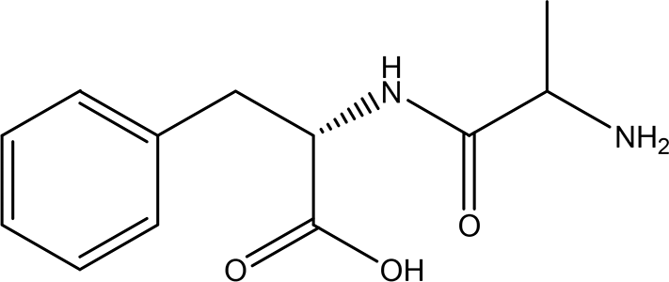 | ACE and Renin inhibitor | Water | Pubchem: 2080
 |  | L-phenylalanine |  | Anti-hypertension |  | SDBS:4845
 |  | C12H16N2O3 |  | DPP IV inhibitor
 |  | C12H16N2O3 |  | Anti-hyperglycemia
 |  |  |  | (anti-diabetes) (Gallego et al., 2019; Messerli et al.,
 |  |  |  | 2018; Deacon, 2020; Fisher and Meagher, 2011).
 |  | n-isovaleryl- | 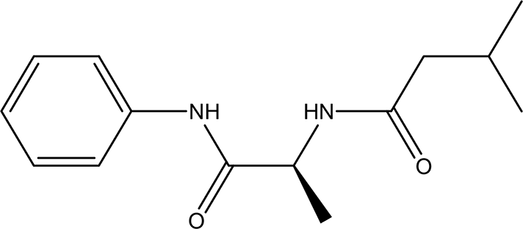 | Anilide derivatives with glycine | Water | Pubchem:
 |  | L-alanine |  | Anti-convulsions of Epilepsy (Soyer et al., 2013). |  | 564405
 |  | anilide C14H20N2O2 |  | Anti-hypertension, anti-diabetes and antioxidant (Gallego et al., 2019). |  | SDBS:32067
Dipeptide are reported to have anti-diabetes activity as stated my some of previously published articles.

F1000Research 2025, 14:872 Last updated: 22 OCT 2025
Page 17 of 30

Table 6. The amino acids derivatives in the water extract of the drones and workers of Apis mellifera jemenitica.

 | Class | Compound | Chemical structure | Biological activity | Extract | ID
6 | Amino acid derivatives | L-glutamic acid 5-hydrazide C5H11N3O3 H2O | 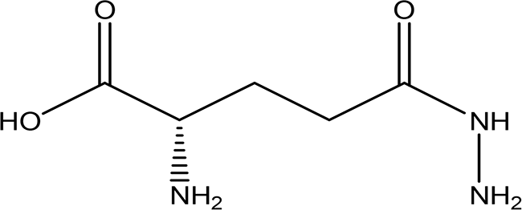 | It has strong mutagenic activity on E coli (Maeda et al., 2021). Ii is involved in the anabolism of fosfazinomycin and kanamycin (Wang et al., 2018). | Water | Pubchem: 92165 SDBS:29556
6 | Amino acid derivatives | (R)-noradrenaline C8H11NO3 | 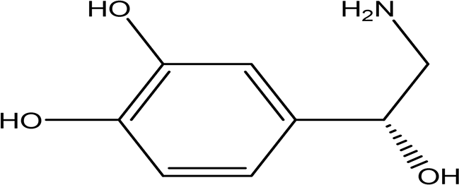 | It is a neurotransmitter and vasoconstrictor used for the treatment of hypotension (Smith and Maani, 2024). | Water | Pubchem: 439260 SDBS:3536
6 | Amino acid derivatives | N (alpha)-benzoyl-DL- arginine-p-nitroanilide hydrochloride C₁₉H₂₂N₆O₄ HCl | 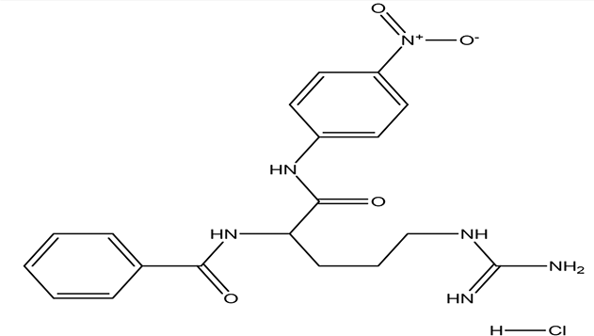 | Enhance proteolytic activity of plasmin and trypsin (Christensen and, Müllertz, 1974; Dulay et al., 2005). | Water | Pubchem: NA SDBS:12532
6 | Amino acid derivatives | 1-nitroguanidine CH₄N₄O₂ | 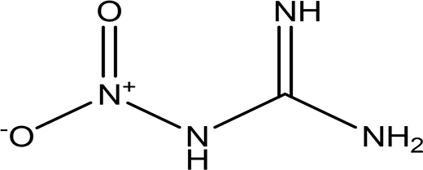 | Component of insecticides and explosives (National Center for Biotechnology Information, 2024k). | Water | Pubchem: 86287517 SDBS:3695
The amino acids derivatives are specific to the water extracts with variable functions for the honeybee. Presence of 1-nitroguanidine may be due to environmental pollution.

F1000Research 2025, 14:872 Last updated: 22 OCT 2025
Page 18 of 30

Table 7. The organometallic compounds and pesticides in the water extract of the drones and workers of Apis mellifera jemenitica.

 | Class | Compound | Chemical structure | Biological activity | Extract | ID
7 | Organometallic compounds | Pentaammine (chloroacetato) cobalt (III)diperchlorate C₂H₁₇Cl₃CoN₅O₁₀ | NA | Used in synthesis of explosive material (Ilyushin et al., 2010). | Water | Pubchem: NA SDBS:35464
7 | Organometallic compounds | Potassium diaquabis (malonato) manganite (III)  C₆H₈KMnO₁₀ 2H₂O | NA | synthetic Inorganic compound with magnetic activity (Delgado et al., 2006). | Water | Pubchem: NA SDBS:26382
7 | Organometallic compounds | alpha-chloralose C8H11Cl3O6 | 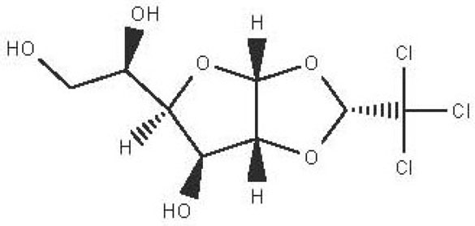 | Pesticide, anesthetic, hypnotics and sedatives (National Center for Biotechnology Information, 2024^{l}). | Ethanol | Pubchem: 7057995 SDBS:3495
The presence of the organometallic compounds may be referred to environmental pollution.

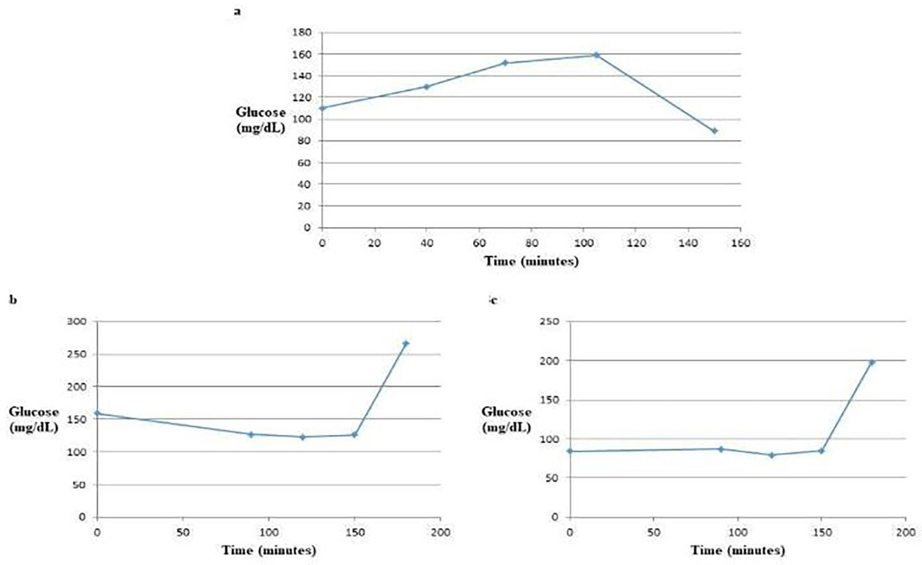

Figure 3. The GTT Curves of glucose alone (a), glucose with water extract (b) and glucose with ethanol extract (c). The water extract altered the GTT curve from a convex shape to a concave shape, indicating a significant effect on blood glucose levels. In contrast, the ethanol extract demonstrated a more variable response, showing a slight increase, followed by a slight decrease, and then a subsequent increase in blood glucose levels. This suggests different mechanisms of action or efficacy between the two extracts in influencing glucose tolerance.

Table 8. Blood glucose concentration (mg/dL) of the GTT experiments.

Time of blood sample | GTT | Mean | SD | Minimum | Maximum
Fasting | Control | 97.50*$ | 17.68 | 85.00 | 110.00
Fasting | Glucose+ water extract | 136.50$@ | 31.82 | 114.00 | 159.00
Fasting | Glucose + ethanol extract | 97.00$ | 18.38 | 84.00 | 110.00
After 90 minutes | Control | 114.50#$ | 21.92 | 99.00 | 130.00
After 90 minutes | Glucose+ water extract | 120.50$ | 9.19 | 114.00 | 127.00
After 90 minutes | Glucose+ ethanol extract | 90.00$ | 4.24 | 87.00 | 93.00
After 120 minutes | Control | 173.00*#$&@ | 29.70 | 152.00 | 194.00
After 120 minutes | Glucose+ water extract | 123.50$ | .71 | 123.00 | 124.00
After 120 minutes | Glucose + ethanol extract | 82.50$ | 4.95 | 79.00 | 86.00
After 150 minutes | Control | 100.50$& | 16.26 | 89.00 | 112.00
After 150 minutes | Glucose+ water extract | 115.50$ | 14.85 | 105.00 | 126.00
After 150 minutes | Glucose + ethanol extract | 124.50 | 27.58 | 105.00 | 144.00
After 180 minutes | Control | 87.50$@ | 10.61 | 80.00 | 95.00
After 180 minutes | Glucose+ water extract | 236.00*#&@ | 43.84 | 205.00 | 267.00
After 180 minutes | Glucose + ethanol extract | 192.00*#&@ | 7.07 | 187.00 | 197.00
The glucose concentration in the GTT control group was significantly different from its concentration in the other groups. This significant variation (p-value ≤ 0.05) is indicated by five symbols: *, #, $, &, and @. The ANOVA analysis results, including the p-values, are attached to this article as a supplementary file (Supplement.4).

received glucose combined with honeybee water extract, and another group that received glucose combined with honeybee ethanol extract. This setup aimed to assess the effects of the honeybee extracts on glucose metabolism compared to the control group. The results of the blood glucose concentration in the three groups and in the different time intervals are presented in Table 8.

- Discussion This study can be seen as the first to report the presence of bioactive natural products such as polyphenols, alkaloids, and quinones in the whole body constituents of A. m. jemenitica drones and workers. Previously published articles have primarily focused on the nutritional value of honeybees and their larvae and pupae, emphasizing their content of amino acids, fatty acids, proteins, minerals, and vitamins (Guiné et al., 2022; Ghosh et al., 2016).

  - Chemical composition of the water and ethanol extracts
    - Sugars and their derivatives

The water extract contained one sugar, L-fucose, whereas the ethanol extract contained two sugars, L-fucose and D-fucose, along with two sugar derivatives. ((S)-1,2-O-(2,2,2-trichloroethylidene)-alpha-D-glucofuranose and methyl 2,3,4-tri-O-acetyl-1-deoxy-1-(propoxy (thiocarbonyl))amino-beta-D-glucopyranuronate).

      - L-fucose (6-deoxy-beta-L-galactopyranose)

Fucose was identified in both the water and ethanol extracts, and it stands out as the only deoxy monosaccharide present in mammals in the L-form, while most other monosaccharides exist in their D-form. Known as 6-deoxy-beta-L-galactose, fucose typically adopts a pyranose configuration and exhibits a crystalline white appearance, with a molecular formula of C₆H₁₂O₅ (Table 1 and Table 2). This compound is commonly found at the terminal positions of oligosaccharides, polysaccharides, and glycolipids. L-fucose is abundant in various organisms, such as brown algae, marine microalgae (which include both green and red algae, as well as diatoms), bacteria, and fungi (Wang et al., 2024).

In terms of functionality, L-fucose plays significant roles in both medicine and industry. It has been recognized for its antitumor and anti-aging properties, and it can also alleviate intestinal pain. Industrially, L-fucose serves as an emulsifier in the food industry and is incorporated into various skin care products (Adhikari et al., 2022; Garber et al., 2021; Al- Baarri et al., 2018; Fiume et al., 2019).

      - D-fucose (6-deoxy-D-galactose)

D-fucose is a stereoisomer of L-fucose. Unlike L-fucose, which is more prevalent in human fluids, D-fucose has been reported to exhibit anti-acrosin activity. Acrosin is a sperm protease that plays a crucial role in the fertilization of ova (National Center for Biotechnology Information, 2024a; Klemm et al., 1991). Notably, D-fucose was identified in the ethanol extract but was not detected in the water extract, as shown in Table 2.

      - (S)-1,2-O-(2,2,2-trichloroethylidene)-alpha-D-glucofuranose (beta-Chloralose)

This derived monosaccharide is detected in the ethanol extract. It was historically used as a sedative drug, but due to its side effects and limited effectiveness, it has been largely replaced by safer and more effective sedatives. Nevertheless, it still finds application as a general anesthetic for animals. In a medical context, it is utilized to relieve psychological excitement by inducing drowsiness and promoting sleep (see Table 2 for further details) (National Center for Biotech- nology Information, 2024b).

      - Methyl 2,3,4-tri-O-acetyl-1-deoxy-1-(propoxy (thiocarbonyl))amino-beta-D-glucopyranuronate

As a glucuronic acid derivative, Methyl 2,3,4-tri-O-acetyl-1-deoxy-1-(propoxy (thiocarbonyl))amino-beta-D- glucopyranuronate may enhance bone matrix deposition and decrease bone resorption. This compound could achieve these effects through the activation of osteoblastic cell differentiation while simultaneously inhibiting osteoclastic cell differentiation. This dual action may contribute to improved bone health and density (Nagaoka et al., 2012). The Methyl 2,3,4-tri-O-acetyl-1-deoxy-1-(propoxy (thiocarbonyl))amino-beta-D-glucopyranuronate was not detected in the water extract (Table 2).

    - Phenolic compounds

      - 2,4,6-trimethylpyridinium p-toleunesulfonate

The 2,4,6-trimethylpyridinium p-toluenesulfonate was detected in the water extract. It is a white to pale yellow or orange solid with the molecular formula C₁₅H₁₉NO₃S. This compound is commonly used in chemical synthesis, serving as a significant reagent in various organic reactions (Chemical Book. 2023). Its presence in the extracts underlines the varied chemical constituents that could affect the GTT curve.

      - 2,4-dihydroxybenzoic acid

2,4-Dihydroxybenzoic acid was identified in the water extract of A. m. jemenitica. It has the molecular formula C₇H₆O₄, appears as a solid, and is characterized by a white color. This compound is commonly found in various plants (Table 2) and is utilized in the food industry as a flavoring agent. In the plant kingdom, 2,4-dihydroxybenzoic acid is known to play a crucial role in enhancing disease resistance (National Center for Biotechnology Information, 2024c; Lu et al., 2024). Additionally, it possesses notable antioxidant and antimicrobial properties (Kalinowska et al., 2021).

      - 2,3-naphthalenediol

2,3-naphthalenediol is a white powder with the molecular formula C₁₀H₈O₂. It is recognized as a human metabolite and is utilized as a hair dyeing material (Table 2) (National Center for Biotechnology Information, 2024d). Naphthalenediols exhibit a range of biological activities, including antioxidant, antilplatelet aggregation, anti-inflammatory, antimicrobial, and anti-protozoal effects (Ibrahim and Mohamed, 2016).

      - 6-methyl-2-benzothiazolamine

6-methyl-2-benzothiazolamine was identified in the water extract. It is solid in nature with the molecular formula of C₈H₈N₂S (Table.2) (National Center for Biotechnology Information, 2024e). Benzothiazole derivatives are proven to exhibit various biological activities, including anticancer, anti-tuberculosis, antimicrobial, anti-inflammatory, anti- convulsant, and anti-diabetic properties (Ali and Siddiqui, 2013; Dhadda et al., 2021).

      - 3-amino-4-hydroxybenzenesulfonic acid

The compound mentioned is a brown solid with the molecular formula C₆H₇NO₄S, identified as 3-amino- 4-hydroxybenzenesulfonic acid (Table.2) (National Center for Biotechnology Information, 2024f). This compound exhibits inhibitory effects on a variety of enzymes, including Coenzyme A dehydrogenase, Aldehyde dehydrogenase, and Apurinic/apyrimidinic endonuclease. Additionally, it has been reported to have anticancer properties, particularly in the context of leukemia. The compound also acts as an antagonist for certain receptors, specifically retinoid-related orphan receptor gamma, while functioning as an agonist for some signaling pathways, notably the peroxisome proliferator-activated receptor delta signaling pathway (National Center for Biotechnology Information, 2024f).

      - 5-(p-aminophenyl)-2-thiazolamine

5-(p-aminophenyl)-2-thiazolamine is a notable water extract with the molecular formula C₉H₉N₃S. This compound features an aminophenol moiety and is incorporated into nano-pigments used for printing applications (Table 2) (National Center for Biotechnology Information, 2024g). In addition to its use in printing, aminophenol derivatives are recognized for their antimicrobial and anti-diabetic activities. Specifically, compounds that possess thiazolamine and aminophenol structures have demonstrated antimicrobial properties, with sulfathiazol being a prominent example (Rafique et al., 2022; Ali and Sayed, 2021).

      - 3’-hydroxy-2’-acetonaphthone

3’-Hydroxy-2’-acetonaphthone has the molecular formula C₁₂H₁₀O₂ and has been identified in the water extract of A. m. jemenitica. As a naphthene derivative, acetonaphthone is noted for its potential antimicrobial and anti- convulsant properties, as indicated by Karakurt et al. (2010) and Center for Advancing Translational Sciences (2020).

      - 4-nitro-2-(trifluoromethyl)aniline

The compound 4-nitro-2-(trifluoromethyl) aniline, with the molecular formula C₇H₅F₃N₂O₂, is primarily utilized in the synthesis of mono-azo dyes (Dickey et al., 1953). Additionally, trifluoromethyl compounds have shown potential in the treatment of various diseases, serving as effective agents in anti-tuberculosis, antiviral, anticancer, and antidepressant applications (Nair et al., 2022).

      - 5,6-dihydro-4H-benzo(6,7)cyclohepta(1,2-d)thiazol-2-amine hydrobromide

5,6-Dihydro-4H-benzo(6,7)cyclohepta(1,2-d)thiazol-2-amine hydrobromide is classified as a tricyclic thiazole com- pound. This compound features derivatives of benzene, cycloheptane, and thiazole, making it a unique structure. It has been noted for its biological activity, particularly as an anti-angiogenesis agent, which suggests it may play a role in inhibiting the growth of new blood vessels that can contribute to tumor development and other pathological conditions. Studies exploring its potential therapeutic applications could be of great interest in drug development and cancer treatment (Bhat et al., 2013).

      - O-(N-(dimethylcarbamoylmethyl)acetamido)-N-N-dimethylbenzamide

O-(N-(dimethylcarbamoylmethyl)acetamido)-N,N-dimethylbenzamide is classified as a urea derivative. Urea deriva- tives, which include compounds like acetamide and benzamide, are commonly utilized in drug design. Notable examples include glibenclamide and cariprazine, which are used for treating various conditions. These derivatives have applica- tions in the treatment of certain cancers, epilepsy, viral infections such as hepatitis C and HIV, as well as Alzheimer’s disease (Ghosh and Brindisi, 2019; Matošević and Bosak, 2020). Additionally, compounds containing acetamide and benzamide are known to function as urease inhibitors, highlighting their significance in pharmacological research and potential therapeutic uses (Ahmad et al., 2023a).

      - 8-cyano-3,3-diphenyl-3,3a-dihydrocyclohepta(b)furan-2-one

The eleventh phenolic compound identified in the water extract has the molecular formula C₂₂H₁₅NO₂. Recognized as a benzofuran, the compound 8-cyano-3,3-diphenyl-3,3a-dihydrocyclohepta(b)furan-2-one exhibits potential biological activities such as antimicrobial, anti-tumor, anti-inflammatory, and antioxidant properties. This highlights its significance in terms of therapeutic applications and its potential benefits in health and medicine (Miao et al., 2019).

      - 2-ethylthio (thiocarbonyl)amino-phenylpropionic acid cyclohexylamine salt

The twelfth compound of the water extract is composed of phenylpropanoid derivative and cyclohexylamine. Phenyl- propanoids are known for their various biological activities, including antimicrobial, antioxidant, anti-inflammatory, anti-diabetic, and anticancer properties. Additionally, they play a protective role for the kidneys, neurons, heart, and liver (Neelam et al., 2020). Conversely, cyclohexylamine derivatives demonstrate analgesic effects and can result in decreased motor activity (Glushkov et al., 2006).

      - Tiropramide hydrochloride

Tiropramide hydrochloride is a phenolic compound with the molecular formula C₂₈H₄₂ClN₃O₃. It is well-known for its anti-spasmodic properties and is commonly used in the treatment of various conditions related to the hepatobiliary and urinary tracts, including Irritable Bowel Syndrome (IBS) (National Center for Biotechnology Information, 2024h, Lee et al., 2013; Center for Advancing Translational Sciences, 2024).

      - 2- methyl-1,2,3,4-tetrahydro-2-naphthol

2-Methyl-1,2,3,4-tetrahydro-2-naphthol has the molecular formula C₁₁H₁₄O. Naphthol derivatives have been shown to act as antioxidants and acetylcholinesterase inhibitors, which are important since acetylcholinesterase is a marker for degenerative neurological diseases. The antioxidant properties of these compounds may provide protective effects against oxidative stress, while the inhibition of acetylcholinesterase suggests potential therapeutic applications in managing neurological disorders (Erdoğan et al., 2021).

      - (4aalpha, 7alpha, 9alpha, 9aalpha)-9-9a-epoxy-1,1,41,7-tetramethyl-2,3,4,4a,5,6,7,8,9,9a-decahydro-1H- benzocyclohepten-7-ol

As a benzocycloheptane derivative, (4aα, 7aα, 9aα, 9aα)-9-9a-epoxy-1,1,4,7-tetramethyl-2,3,4,4a,5,6,7,8,9,9a- decahydro-1H-benzocyclohepten-7-ol has the potential to exhibit antihistamine activity, in addition to demonstrating effectiveness in killing hepatoma cells (Abounassif et al., 2005; Liang et al., 2020).

      - Ethyl p-((2-chloroethoxy) carbonylamino) benzoate

Benzoate derivatives are well-known for their diverse biological activities, including functions as local anesthetics, anticancer agents, anti-Alzheimer compounds, and antimicrobial, antioxidant, and anti-inflammatory agents (Zou et al., 2019; Haroon et al., 2023). Additionally, these derivatives are utilized in agricultural applications as pesticides (Lee et al., 2023; Elabasy et al., 2019).

      - Lasalocid Sodium Salt

Lasalocid Sodium Salt is a benzoate derivative that contains lasalocid. Its molecular formula is C₃₄H₅₃NaO₈. In veterinary medicine, it serves dual functions as an antibacterial agent and an ionophore. As an ionophore, it enhances calcium influx in muscle fibers, which can have various therapeutic effects (National Center for Biotechnology Information, 2024i).

      - Methyl 4-(3,5-dichloro-4-methoxyphenyl)-3-ethyl-1-pyrazoline-3-carboxylate

The above compound contains two bioactive moieties: methoxyphenyl and pyrazoline. Compounds with methoxyphenol exhibit antibacterial activity against food spoilage bacteria and possess antioxidant properties (Orlo et al., 2021; Ahmad et al., 2023b). Pyrazole derivatives are well known for their range of pharmacological activities, which include anticancer, anti-inflammatory, antiviral, antifungal, antioxidant, anti-obesity, antidepressant, antipsychotic, and analgesic effects (Karrouchi et al., 2018; Hassan, 2013).

      - 2’,7’-dihydroxyspiro (isobenzofuran-1(3H),9’-(9H)xanthen)-3-one

The nineteenth phenolic compounds contain two bioactive moieties: benzofuran and xanthen-3-one. Benzofuran derivatives are well-known for their antitumor, antiviral, antibacterial, and antioxidant properties (Miao et al., 2019). On the other hand, xanthen-3-one derivatives exhibit notable anticancer and anti-proliferative activities (Zukić et al., 2020).

    - Alkaloids

      - 2-(5-methyl-3-pyrroly) piperidine hydrochloride

Natural and synthetic piperdines are known for their diverse biological activities, including anticancer, antioxidant, anti- Alzheimer, antimicrobial, and anti-neuropathic pain properties (Frolov and Vereshchagin, 2023). Additionally, piper- idine exhibits effectiveness against hypertension, asthma, and inflammation (Abdelshaheed et al., 2021).

      - 3-methyl-4-oxo-3,4-dihydro-1-phthalazinecarbohydrazide

The compound contains two bioactive moieties: phthalazine and carbohydrazide. Phthalazine derivatives are recognized for their activity against several health issues, including cancer, diabetes, hypertension, microbial infections, and depression, as well as their analgesic properties (Sangshetti et al., 2019). On the other hand, carbohydrazide derivatives exhibit a range of biological activities, including antibacterial, antifungal, anti-inflammatory, and anti-tuberculosis effects (Onyeyilim et al., 2022).

      - N-(5-chloro-6-oxo-1-phenyl-1,6-dihydro-4-pyridazinyl)acetamide

The bioactive moieties of this compound are the pyridazine and acetamide. Pyridazine derivatives are reported to possess antitumor (He et al., 2021), antibacterial, and antifungal properties (Butnariu and Mangalagiu, 2009). In contrast, acetamide derivatives are known for their antioxidant and anti-inflammatory effects (Autore et al., 2010).

      - 3’-(9-methyl-9H-pyridazino(3,4-b)indol-3-yl)acetanilide

The compound 3’-(9-methyl-9H-pyridazino(3,4-b)indol-3-yl) acetanilide is notable for containing three significant bioactive groups: pyridazine, indole, and acetanilide. Pyridazine derivatives are particularly recognized for their anticancer, antibacterial, and antifungal activities (He et al., 2021; Butnariu and Mangalagiu, 2009). Indole derivatives, on the other hand, exhibit a wide range of biological activities including antimicrobial, anti-malarial, anti-diabetic, anti- inflammatory, and anti-tuberculosis effects (Kumar and Ritika, 2020). Furthermore, acetanilide derivatives are known for their diverse therapeutic actions, which encompass analgesic, anti-inflammatory, antipyretic, antioxidant, anticonvul- sant, antimicrobial, anticancer, anti-hyperglycemic, and antimalarial activities (Singh et al., 2019).

      - 2-hydrazino-3,5,6,7-tetrahydrocyclopentapyrimidin-4-one

2-Hydrazino-3,5,6,7-tetrahydrocyclopentapyrimidin-4-one is classified as both a hydrazine derivative and a cyclopentapyrimidin-4-one derivative. Hydrazine derivatives are known for their potential as carbonic anhydrase inhibitors. These inhibitors play a significant role in treating a variety of conditions, including glaucoma, edema, obesity, osteoporosis, epilepsy, and certain types of cancer (Goff and Ouazzani, 2014; Shirinzadeh and Dilek, 2020). On the other hand, cyclopentapyrimidin-4-one derivatives are recognized for their ability to inhibit Phosphodiesterase10A, making them potential therapeutic targets for various neurodegenerative disorders (Al-Nema et al., 2022; Bhawale et al., 2023).

      - Cytochalasin E

It is an alkaloid drug used for the inhibition of angiogenesis and it increases the sensitivity of lung cancer to medication (National Center for Biotechnology Information, 2024j; Takanezawa et al., 2018).

      - 1,4’-bipiperidine

As noted earlier, piperidine derivatives have demonstrated a range of biological activities, including anticancer, antioxidant, anti-Alzheimer, antimicrobial, anti-neuropathic pain, anti-hypertensive, anti-asthmatic, and anti- inflammatory effects (Frolov and Vereshchagin, 2023; Abdelshaheed et al., 2021).

    - Quinones

      - 4,5-dianilino-O-benzoquinone

4,5-Dianilino-O-benzoquinone is reported to have weak antitumor activity (Huang et al., 1993). Ortho and para benzoquinones are routinely used for their various therapeutic effects, including antimalarial, anti-Alzheimer, antiviral, antifungal, antibacterial, and antitumor properties (Zhang et al., 2021).

      - 1-amino-2-bromo-4-hydroxyanthraquinone

As an anthraquinone derivative, 1-amino-2-bromo-4-hydroxyanthraquinone may exhibit a range of beneficial pharma- cological properties, including antioxidant, anticancer, anti-inflammatory, and anti-aging effects. Additionally, studies suggest that anthraquinone derivatives possess hepatoprotective and neuroprotective activities, contributing to their potential therapeutic applications in various medical fields (Zhao and Zheng, 2023).

      - 2,5-bis(2-hydroxypropylamino)-p-benzoquinone

Benzoquinone derivatives exhibit a range of medicinal properties, making them significant in pharmacology. They have been studied for their antimalarial, anti-Alzheimer, antiviral, antifungal, antibacterial, and antitumor activities (Zhang et al., 2021).

      - 2,5,6-trihydroxy-1,4-naphthoquinone

1,4-naphthoquinones are studied as natural products and have exhibited anticancer and antibacterial activities (Nema- tollahi et al., 2012). Additionally, Li et al. (2018) stated that naphthoquinone derivatives possess cytotoxicity, antiox- idant, and anti-inflammatory activities.

    - Dipeptides

      - DL-alanyl-L-phenylalanine

Dipeptides containing alanine from dry cured ham have been reported to have the ability to inhibit angiotensin-converting enzyme (ACE) and dipeptidyl peptidase IV (DPP IV), making them potential candidates for anti-hypertension and anti- hyperglycemic therapeutic agents, respectively (Gallego et al., 2019; Messerli et al., 2018; Deacon, 2020). Dipeptides that include phenylalanine also exhibit inhibition of ACE and renin, further establishing their suitability as anti- hypertensive compounds (Gallego et al., 2019; Messerli et al., 2018; Fisher and Meagher, 2011). However, our review of the literature reveals a lack of articles documenting the presence of the Ala-Phe (AF) dipeptide in food, biological fluids, or tissues. Consequently, the functional role of the AF sequence has not been previously addressed.

      - n-isovaleryl-L-alanine anilide

Anilide derivatives with amino acids exhibit potential anti-convulsant properties, as seen with glycine anilide derivatives (Soyer et al., 2013). Additionally, dipeptides that include valine or alanine have been shown to inhibit enzymes such as ACE, renin, and DPP IV, indicating their possible roles in managing hypertension and diabetes. Furthermore, dipeptides containing valine residues are noted for their antioxidant activity (Gallego et al., 2019).

    - Amino acid derivatives

      - L-glutamic acid 5-hydrazide

L-glutamic acid, 5-hydrazide exhibits significant mutagenic activity on E. coli, which qualifies it to function as an antibacterial agent (Maeda et al., 2021). It plays a role in the bacterial biosynthesis of important antibiotics such as fosfazinomycin and kanamycin (Wang et al., 2018). This highlights its potential relevance in both medicinal and microbiological contexts.

      - R-noradrenaline

Noreadrenaline, also known as norepinephrine, is a neurotransmitter and hormone that plays a crucial role in the body’s response to stress and blood pressure regulation. It is synthesized from the amino acids tyrosine and phenylalanine (Dalangin et al., 2020). Norepinephrine primarily functions as a vasoconstrictor, making it an important agent in the treatment of hypotension (Smith and Maani, 2024).

      - N (alpha)-benzoyl-DL-arginine-p-nitroanilide hydrochloride

N (alpha)-benzoyl-DL-arginine-p-nitroanilide has the capability of enhancing the proteolytic activity of plasmin and trypsin (Christensen and, Müllertz, 1974; Dulay et al., 2005). The plasmin is involved in the breakdown of the fibrin fibers in blood clots converting them to soluble products (Famutimi et al., 2024). This compound may be exploited in the treatment of ischemic vascular diseases. Trypsin is a serine protease which facilitates the digestion of proteins and it is involved in progression of colorectal and ovarian cancers (National Center for Biotechnology Information, 2024k).

      - 1-nitroguanidine

Nitroguanidine is likely synthesized from arginine and plays a significant role in the structure of various insecticides and explosives (National Center for Biotechnology Information, 2024k; Berlinck and Romminger, 2016). The presence of this compound in the structure of honeybees may be attributed to their exposure to insecticides.

    - Organometallics and pesticides

      - Pentaammine (chloroacetato) cobalt (III) diperchlorate

Pentaammine (chloroacetato) cobalt (III) diperchlorate is reacted with 4-Amino-1,2,4-triazole to produce (4-amino- 1,2,4-triazole-N1(N2) pentaamminocobalt (III) perchlorate; an explosive material with low toxicity (Ilyushin et al., 2010). The existence of this organometallic compound in the water extract of the honeybees may be attributed to environmental pollution, presence in insecticide composition or similarity in IR spectra.

      - Potassium diaquabis (malonato) manganite (III)

It is as synthetic organometallic compound with magnetic activity (Delgado et al., 2006). This compound may found in the water extract of honeybees due to external sources.

      - Alpha-chloralose

Alpha-chloralose is used as pesticides and it is classified as ultra-short acting anesthetic that induces loss of consciousness or as hypnotics and sedatives that induces drowsiness or sleep (National Center for Biotechnology Information, 2024l).

  - Effect the water and ethanol extracts on the GTT curves
The normal GTT curve exhibits various patterns, including monophasic (characterized by one peak with subsequent increase and decrease), biphasic (featuring two peaks), triphasic (showing three peaks), and multi-phasic responses. This curve serves as an indicator of the physiological, metabolic, or pathological state of the subjects, whether humans or animals (de Andrade Mesquita et al., 2018; Vejrazkova et al., 2023).

According to de Andrade et al. (2018), a monophasic GTT curve signals pre-diabetes and pre-metabolic syndrome [104].

The water extract’s impact on the GTT curve is likely attributed to its rich content of phenolic acids and alkaloids, as supported by various studies (Ali and Siddiqui, 2013; Neelam et al., 2020; Sangshetti et al., 2019; Kumar and Ritika, 2020; Singh et al., 2019; Lin et al., 2016; Kumar et al., 2019). Notably, the presence of five specific compounds in the water extract could help elucidate the observed decrease in glucose levels during the second phase of the water extract GTT curve. The five compounds are 6-methyl-2-benzothiazolamine, 5-(p-aminophenyl)-2-thiazolamine, 2-ethylthio (thiocarbonyl)amino-phenylpropionic acid cyclohexylamine salt, 3-methyl-4-oxo-3,4-dihydro-1- phthalazinecarbohydrazide and 3’-(9-methyl-9H-pyridazino(3,4-b)indol-3-yl) acetanilide (Table.2 and Table.3).

- Limitations
This study has certain limitations, including the small sample size of experimental rabbits and a somewhat un ideal discussion section (mostly presented as a review) due to the scarcity of published literature on the chemical composition of honeybee bodies

- Conclusions The water extract of the whole body of A. mellifera drones and workers is found to be abundant in various compounds, including sugar derivatives, phenolic acids, alkaloids, quinones, amino acid derivatives, and short peptides. When administered, this extract notably altered the GTT curve from a convex shape to a concave shape, indicating its potential anti-hyperglycemic properties. The observed anti-hyperglycemic effect is likely attributed to the presence of dipeptides, phenolic acids and alkaloids within the water extract.

Data availability statement
[Figure Share]. [GTT Curves of Water and Ethanol Extracts of Whole Body A. m. jemenitica]. [https://doi.org/10.6084/m9.figshare.29339888] (Mohammed et al., 2025).

This project contains the following underlying data:

- Supplement.1. (Shows the searching the SDBS database).

- Supplement.2. (Shows the SDBS search results displaying the 39 compounds detected in the water extract of Apis mellifera jementica).

- Supplement.3. (Presents the SDBS search results showing the 12 compounds identified in the ethanol extract of Apis mellifera jementica).

- Supplement.4. (Displays the ANOVA test analysis report for the blood glucose level).

- Supplement.5. ARRIVE Checklist

- Supplement.6. The raw data of the blood glucose level

Data is available under the terms of the [CC0].

References

Abdelshaheed MM, Fawzy IM, El-Subbagh HI, et al.: Piperidine nucleus in the field of drug discovery. Futur. J. Pharm. Sci. 2021; 7: 188.
Publisher Full Text
Abounassif MA, El-Obeid HA, Gadkariem EA: Stability studies on some benzocycloheptane antihistaminic agents. J. Pharm. Biomed. Anal. 2005; 36(5): 1011–1018.
PubMed Abstract|Publisher Full Text
Adhikari E, Liu Q, Burton C, et al.: L-fucose, a sugary regulator of antitumor immunity and immunotherapies. Mol. Carcinog. 2022; 61: 439–453.
PubMed Abstract|Publisher Full Text|Free Full Text
Ahmad MS, Siddique AB, Khalid M, et al.: Synthesis, antioxidant activity, antimicrobial efficacy and molecular docking studies of
4-chloro-2-(1-(4-methoxyphenyl)-4,5-diphenyl-1H-imidazol-2-yl) phenol and its transition metal complexes. RSC Adv. 2023a; 13(14): 9222–9230.
PubMed Abstract|Publisher Full Text|Free Full Text
Ahmad S, Qadir MA, Ahmed M, et al.: Exploring the Potential of New Benzamide-Acetamide Pharmacophore Containing Sulfonamide as Urease Inhibitors: Structure–Activity Relationship, Kinetics Mechanism, and In Silico Studies. ACS Omega. 2023b; 8(48):
46165–46181.
PubMed Abstract|Publisher Full Text|Free Full Text
Al-Baarri AN, Legowo AM, Widayat ASBM, et al.: Potential of L-fucose isolated from Brown Seaweeds as Promising Natural Emulsifier compare to Carboxymethyl Cellulose (CMC). IOP Conf. Ser.: Earth Environ. Sci. 2018; 116: 012005.
Publisher Full Text
Ali R, Siddiqui N: Biological Aspects of Emerging Benzothiazoles: A Short Review. J. Chem. 2013; 2013: 345198.
Publisher Full Text
Ali SH, Sayed AR: Review of the synthesis and biological activity of thiazoles. Synth. Commun. 2021; 51(5): 670–700.
Publisher Full Text
Al-Nema M, Gaurav A, Lee VS, et al.: Structure-based discovery and bio- evaluation of a cyclopenta[4,5]thieno[2,3-d]pyrimidin-4-one as a phosphodiesterase 10A inhibitor. RSC Adv. 2022; 12(3): 1576–1591.
PubMed Abstract|Publisher Full Text|Free Full Text
Autore G, Caruso A, Marzocco S, et al.: Acetamide Derivatives with Antioxidant Activity and Potential Anti-Inflammatory Activity. Molecules. 2010; 15(3): 2028–2038.
PubMed Abstract|Publisher Full Text|Free Full Text
Berlinck RG, Romminger S: The chemistry and biology of guanidine natural products. Nat. Prod. Rep. 2016; 33(3): 456–490.
PubMed Abstract|Publisher Full Text
Bhat S, Shim JS, Liu JO: Tricyclic thiazoles are a new class of angiogenesis inhibitors. Bioorg. Med. Chem. Lett. 2013; 23(9): 2733–2737. PubMed Abstract|Publisher Full Text|Free Full Text
Bhawale RT, Chillal AS, Kshirsagar UA: 4H-Pyrido[1,2-a]pyrimidin-4-one, biologically important fused heterocyclic scaffold: Synthesis and functionalization. J. Heterocyclic Chem. 2023; 60(8): 1356–1373.
Publisher Full Text
Borkovcová M, Mlček J, Adámková A, et al.: Use of Foods Based on Bee Drone Brood: Their Sensory and Microbiological Evaluation and Mineral Composition. Sustainability. 2022; 14(5): 2814.
Publisher Full Text
Butnariu RM, Mangalagiu II: New pyridazine derivatives: Synthesis, chemistry and biological activity. Bioorg. Med. Chem. 2009; 17(7): 2823–2829.
Publisher Full Text
Center for Advancing Translational Sciences: Insight Drugs: 2-Acetopnathone. 2020. October 12, 2024.
Reference Source
Center for Advancing Translational Sciences: Insight Drugs: TIROPRAMIDE HYDROCHLORIDE. October 18, 2024
Reference Source
Chemical Book: 2,4,6-trimethylpyridinium p-toleunesulfonate. 2023. October 11, 2024.
Reference Source
Choi JS: Nutrition, Safety, Health Functional Effects, and Availability of Honeybee (Apis mellifera L.) Drone Pupae. Insects. 2021; 12(9): 771.
PubMed Abstract|Publisher Full Text|Free Full Text
Christensen U, Müllertz S: Mechanism of reaction of human plasmin with α-N-benzoyl-l-arginine-p-nitroanilide: Titration of the enzyme. Biochimica et Biophysica Acta (BBA) – Enzymology. 1974; 334(1): 187–198. Publisher Full Text
Coates J: Interpretation of Infrared Spectra, a Practical Approach. Encyclopedia of Analytical Chemistry. Chichester, UK: John Wiley & Sons; 2006.
Publisher Full Text
Dalangin R, Kim A, Campbell RE: The Role of Amino Acids in Neurotransmission and Fluorescent Tools for Their Detection. Int.
J. Mol. Sci. 2020; 21(17): 6197.
PubMed Abstract|Publisher Full Text|Free Full Text
de Andrade ML, Pavan Antoniolli L, Cittolin-Santos GF, et al.: Distinct metabolic profile according to the shape of the oral glucose tolerance test curve is related to whole glucose excursion: a cross-sectional study. BMC Endocr. Disord. 2018; 18: 56.
PubMed Abstract|Publisher Full Text|Free Full Text
Deacon CF: Dipeptidyl peptidase 4 inhibitors in the treatment of type 2 diabetes mellitus. Nat. Rev. Endocrinol. 2020; 16: 642–653.
Publisher Full Text
Delgado FS, Kerbellec N, Ruiz-PérezJoan C, et al.: Malonate-Containing Manganese (III) Complexes: Synthesis, Crystal Structure, and Magnetic Properties of AsPh4[Mn (mal)2(H2O)2]. Inorg. Chem. 2006; 45(3): 1012–1020.
PubMed Abstract|Publisher Full Text
Dhadda S, Raigar AK, Saini K, et al.: Benzothiazoles: From recent advances in green synthesis to anti-cancer potential. Sustain. Chem. Pharm. 2021; 24: 100521.
Publisher Full Text
Dickey JB, Towne EB, Bloom MS, et al.: Effect of Fluorine Substitution on Color and Fastness of Monoazo Dyes. Ind. Eng. Chem. Res. 1953; 45: 1730–1734.
Publisher Full Text
Dulay MT, Baca QJ, Zare RN: Enhanced proteolytic activity of covalently bound enzymes in photopolymerized sol gel. Anal. Chem. 2005; 77(14): 4604–4610.
PubMed Abstract|Publisher Full Text
Elabasy A, Shoaib A, Waqas M, et al.: Synthesis, Characterization, and Pesticidal Activity of Emamectin Benzoate Nanoformulations against Phenacoccus solenopsis Tinsley (Hemiptera: Pseudococcidae).
Molecules. 2019; 24(15): 2801.
PubMed Abstract|Publisher Full Text|Free Full Text
Erdoğan M, Köse LP, Eşsiz S, et al.: Synthesis and biological evaluation of some 1-naphthol derivatives as antioxidants, acetylcholinesterase, and carbonic anhydrase inhibitors. Arch. Pharm. 2021; 354: e2100113. PubMed Abstract|Publisher Full Text
Eyth E, Basit H, Swift CJ: Glucose Tolerance Test. [Updated 2023 Apr 23].
StatPearls. Treasure Island (FL): StatPearls Publishing; 2024 Jan.
Reference Source
Famutimi OG, Adebiyi VG, Akinmolu BG, et al.: Trypsin, chymotrypsin and elastase in health and disease. Futur. J. Pharm. Sci. 2024; 10: 126.
Publisher Full Text
Fisher NDL, Meagher EA: Renin Inhibitors. J. Clin. Hypertens. (Greenwich).
2011; 13(9): 662–666.
PubMed Abstract|Publisher Full Text|Free Full Text
Fiume MM, Bergfeld WF, Belsito DV, et al.: Safety Assessment of Monosaccharides, Disaccharides, and Related Ingredients as Used in Cosmetics. Int. J. Toxicol. 2019; 38(1_suppl): 5S–38S.
PubMed Abstract|Publisher Full Text
Frolov NA, Vereshchagin AN: Piperidine Derivatives: Recent Advances in Synthesis and Pharmacological Applications. Int. J. Mol. Sci. 2023; 24(3): 2937.
PubMed Abstract|Publisher Full Text|Free Full Text
Gallego M, Mora L, Toldrá F: The relevance of dipeptides and tripeptides in the bioactivity and taste of dry-cured ham. Food Prod. Process. Nutr. 2019; 1: 2.
Publisher Full Text
Garber JM, Hennet T, Szymanski CM: Significance of fucose in intestinal health and disease. Mol. Microbiol. 2021; 115(6): 1086–1093.
PubMed Abstract|Publisher Full Text

Ghosh AK, Brindisi M: Urea Derivatives in Modern Drug Discovery and Medicinal Chemistry. J. Med. Chem. 2019; 63(6): 2751–2788.
PubMed Abstract|Publisher Full Text|Free Full Text
Ghosh S, Jung C, Meyer-Rochow VB: Nutritional value and chemical composition of larvae, pupae, and adults of worker honey bee, Apis mellifera ligustica as a sustainable food source. J. Asia Pac. Entomol. 2016; 19(2): 487–495.
Publisher Full Text
Glushkov VA, P’yankova OS, Anikina LV, et al.: Synthesis and biological activity of cyclohexylamine derivatives. Pharm. Chem. J. 2006; 40: 298–302.
Publisher Full Text
Goff GL, Ouazzani J: Natural hydrazine-containing compounds: Biosynthesis, isolation, biological activities and synthesis. Bioorg. Med. Chem. 2014; 22(23): 6529–6544.
PubMed Abstract|Publisher Full Text
Guarnieri A, Triunfo M, Scieuzo C, et al.: Antimicrobial properties of chitosan from different developmental stages of the bioconverter insect Hermetia illucens. Sci. Rep. 2022; 12(1): 8084.
PubMed Abstract|Publisher Full Text|Free Full Text
Guiné RPF, Florença SG, Correia PMR, et al.: Honey Bee (Apis mellifera L.) Broods: Composition, Technology and Gastronomic Applicability.
Foods. 2022; 11(18): 2750.
PubMed Abstract|Publisher Full Text|Free Full Text
Haroon F, Farwa U, Arif M, et al.: Novel Para-Aminobenzoic Acid Analogs and Their Potential Therapeutic Applications. Biomedicine. 2023; 11(10): 2686.
PubMed Abstract|Publisher Full Text|Free Full Text
Hassan SY: Synthesis, Antibacterial and Antifungal Activity of Some New Pyrazoline and Pyrazole Derivatives. Molecules. 2013; 18(3): 2683–2711.
PubMed Abstract|Publisher Full Text|Free Full Text
He ZX, Gong YP, Zhang X, et al.: Pyridazine as a privileged structure: An updated review on anticancer activity of pyridazine containing bioactive molecules. Eur. J. Med. Chem. 2021; 209: 112946.
PubMed Abstract|Publisher Full Text
Huang ZD, Chen YN, Menon K, et al.: Synthesis and evaluation of the antitumor activity of 4,5-diamino-substituted 1,2-benzoquinones.
J. Med. Chem. 1993; 36(13): 1797–1801.
PubMed Abstract|Publisher Full Text
Ibrahim SRM, Mohamed GA: Naturally occurring naphthalenes: chemistry, biosynthesis, structural elucidation, and biological activities. Phytochem. Rev. 2016; 15: 279–295.
Publisher Full Text
Ilyushin MA, Aleksandrova MA, Bachurina IV, et al.: Synthesis and properties of an energetic complex pentaamminecobalt (III) perchlorate, with 4-amino-1,2,4-triazole as ligand. Russ. J. Appl. Chem. 2010; 83: 92–96.
Publisher Full Text
Kalinowska M, Gołębiewska E, Świderski G, et al.: Plant-Derived and Dietary Hydroxybenzoic Acids-A Comprehensive Study of Structural, Anti-/Pro-Oxidant, Lipophilic, Antimicrobial, and Cytotoxic Activity in MDA-MB-231 and MCF-7 Cell Lines. Nutrients. 2021; 13(9): 3107.
PubMed Abstract|Publisher Full Text|Free Full Text
Karakurt A, Özalp M, Işık S, et al.: Synthesis, anticonvulsant and antimicrobial activities of some new 2-acetylnaphthalene derivatives. Bioorg. Med. Chem. 2010; 18(8): 2902–2911.
PubMed Abstract|Publisher Full Text
Karrouchi K, Radi S, Ramli Y, et al.: Synthesis and Pharmacological Activities of Pyrazole Derivatives: A Review. Molecules. 2018; 23(1): 134. PubMed Abstract|Publisher Full Text|Free Full Text
Khayrova A, Lopatin S, Shagdarova B, et al.: Evaluation of antibacterial and antifungal properties of low molecular weight chitosan extracted from Hermetia illucens relative to crab chitosan. Molecules. 2022; 27(2): 577.
PubMed Abstract|Publisher Full Text|Free Full Text
Klemm U, Müller-Esterl W, Engel W: Acrosin, the peculiar sperm-specific serine protease. Hum. Genet. 1991; 87: 635–641.
PubMed Abstract|Publisher Full Text
Kumar A, Aswal S, Semwal RB, et al.: Role of plant-derived alkaloids against diabetes and diabetes-related complications: a mechanism- based approach. Phytochem. Rev. 2019; 18: 1277–1298.
Publisher Full Text
Kumar S, Ritika.: A brief review of the biological potential of indole derivatives. Futur J. Pharm. Sci. 2020; 6: 121.
Publisher Full Text
Lee JW, Mwamula AO, Choi JH, et al.: Comparative Bioactivity of Emamectin Benzoate Formulations against the Pine Wood Nematode, Bursaphelenchus xylophilus. Plant Pathol. J. 2023; 39(1): 75–87.
PubMed Abstract|Publisher Full Text|Free Full Text
Lee KN, Lee OY, Choi M-G, et al.: Efficacy and Safety of Tiropramide in the Treatment of Patients With Irritable Bowel Syndrome: A Multicenter, Randomized, Double-blind, Non-inferiority Trial, Compared With Octylonium. J. Neurogastroenterol. Motil. 2013; 20(1): 113–121.
PubMed Abstract|Publisher Full Text|Free Full Text
Li CK, Su XM, Li FH, et al.: Reviews on natural naphthoquinones and their bioactivities. Zhongguo Zhong Yao Za Zhi. 2018; 43(18): 3644–3651. Chinese.
Publisher Full Text
Liang YC, Chang CC, Sheu MT, et al.: The Antihistamine Deptropine Induces Hepatoma Cell Death through Blocking Autophagosome- Lysosome Fusion. Cancers (Basel). 2020; 12(6): 1610.
PubMed Abstract|Publisher Full Text|Free Full Text
Lin D, Xiao M, Zhao J, et al.: An Overview of Plant Phenolic Compounds and Their Importance in Human Nutrition and Management of Type 2 Diabetes. Molecules. 2016; 21(10): 1374.
PubMed Abstract|Publisher Full Text|Free Full Text
Lu M, Zhao Y, Feng Y, et al.: 2,4-Dihydroxybenzoic Acid, a Novel SA Derivative, Controls Plant Immunity via UGT95B17-Mediated Glucosylation: A Case Study in Camellia Sinensis. Adv Sci (Weinh). 2024; 11(7): e2307051.
PubMed Abstract|Publisher Full Text|Free Full Text
Maeda T, Shibai A, Yokoi N, et al.: Mutational property of newly identified mutagen l-glutamic acid γ-hydrazide in Escherichia coli. Mutat. Res. 2021; 823: 111759.
PubMed Abstract|Publisher Full Text
Matošević A, Bosak A: Carbamate Group as Structural Motif in Drugs: A Review of Carbamate Derivatives used as Therapeutic Agents. Arh. Hig. Rada Toksikol. 2020; 71(4): 285–299.
PubMed Abstract|Publisher Full Text|Free Full Text
Meda A, Lamien CE, Millogo J, et al.: Therapeutic uses of honey and honeybee larvae in central Burkina Faso. J. Ethnopharmacol. 2004; 95(1): 103–107.
PubMed Abstract|Publisher Full Text
Messerli F, Bangalore S, Bavishi C, et al.: Angiotensin-Converting Enzyme Inhibitors in Hypertension: To Use or Not to Use? JACC. 2018; 71(13): 1474–1482.
Publisher Full Text
Miao Y-h, Hu Y-h, Yang J, et al.: Natural source, bioactivity and synthesis of benzofuran derivatives. RSC Adv. 2019; 9(47): 27510–27540.
PubMed Abstract|Publisher Full Text|Free Full Text
Mohammed M, Tarik TEA, Asseri RMA, et al.: Glucose Tolerance Test (GTT) Curves of Water and Ethanol Extracts of Whole Body Apis mellifera jemenitica. Dataset. figshare. 2025; 2025.
Publisher Full Text
Moro C, Magnan C: Revisited guidelines for metabolic tolerance tests in mice. Lab Anim. 2025; 54: 16–23.
PubMed Abstract|Publisher Full Text|Free Full Text
Mutinelli F: Euthanasia and welfare of managed honey bee colonies.
J. Apic. Res. 2021; 62(1): 2–10.
Publisher Full Text
Nagaoka I, Igarashi M, Sakamoto K: Biological activities of glucosamine and its related substances. Adv. Food Nutr. Res. 2012; 65: 337–352.
PubMed Abstract|Publisher Full Text
Nair AS, Singh AK, Kumar A, et al.: FDA-Approved Trifluoromethyl Group- Containing Drugs: A Review of 20 Years. Processes. 2022; 10(10): 2054. Publisher Full Text
National Center for Biotechnology Information: PubChem Compound Summary for CID 5458385, Cytochalasin E. 2024j. November 14, 2024. Reference Source
National Center for Biotechnology Information: PubChem Compound Summary for CID 86287517, Nitroguanidine. 2024k. November
16, 2024.
Reference Source
National Center for Biotechnology Information: PubChem Compound Summary for CID 7057995, Chloralose. 2024l. November 16, 2024.
Reference Source
National Center for Biotechnology Information: PubChem Compound Summary for CID 19466, D-fucopyranose. 2024a. October 8, 2024.
Reference Source
National Center for Biotechnology Information: PubChem Compound Summary for CID 5284343, beta-Chloralose. 2024b. October 10, 2024. Reference Source
National Center for Biotechnology Information: PubChem Compound Summary for CID 1491, 2,4-Dihydroxybenzoic acid. 2024c. October 11, 2024.
Reference Source
National Center for Biotechnology Information: PubChem Compound Summary for CID 7091, 2,3-Dihydroxynaphthalene. 2024d. October 11, 2024.
Reference Source

National Center for Biotechnology Information: PubChem Compound Summary for CID 17335, 2-Amino-6-methylbenzothiazole. 2024e.
October 12, 2024.
Reference Source
National Center for Biotechnology Information: PubChem Compound Summary for CID 7385, 3-Amino-4-hydroxybenzenesulfonic acid. 2024f. October 12, 2024.
Reference Source
National Center for Biotechnology Information: PubChem Compound Summary for CID 605642, 5-(p-Aminophenyl)-2-thiazolamine. 2024g. October 12, 2024.
Reference Source
National Center for Biotechnology Information: PubChem Compound Summary for CID 134448, Tiropramide hydrochloride. 2024h.
October 18, 2024.
Reference Source
National Center for Biotechnology Information: PubChem Compound Summary for CID 6426773, Lasalocid Sodium. 2024i. October 20, 2024. Reference Source
Neelam, Khatkar A, Sharma KK: Phenylpropanoids and its derivatives: biological activities and its role in food, pharmaceutical and cosmetic industries. Crit. Rev. Food Sci. Nutr. 2020; 60(16): 2655–2675.
PubMed Abstract|Publisher Full Text
Nematollahi A, Aminimoghadamfarouj N, Wiart C: Reviews on 1,4- naphthoquinones from Diospyros L. J. Asian Nat. Prod. Res. 2012; 14(1): 80–88.
PubMed Abstract|Publisher Full Text
Onyeyilim EL, Ezeokonkwo MA, Ugwu DI, et al.: Carbohydrazide Analogues: A Review of Synthesis and Biological Activities. Mini Rev. Med. Chem. 2022; 22(4): 661–682.
PubMed Abstract|Publisher Full Text
Orlo E, Russo C, Nugnes R, et al.: Natural Methoxyphenol Compounds: Antimicrobial Activity against Foodborne Pathogens and Food Spoilage Bacteria, and Role in Antioxidant Processes. Foods. 2021; 10(8): 1807.
PubMed Abstract|Publisher Full Text|Free Full Text
Rafique B, Kalsoom S, Sajini AA, et al.: Synthesis, Characterization, Biological Evaluation and DNA Interaction Studies of 4-Aminophenol Derivatives: Theoretical and Experimental Approach. Molecules. 2022; 27(4): 1352.
PubMed Abstract|Publisher Full Text|Free Full Text
Sangshetti J, Pathan SK, Patil R, et al.: Synthesis and biological activity of structurally diverse phthalazine derivatives: A systematic review.
Bioorg. Med. Chem. 2019; 27(18): 3979–3997.
PubMed Abstract|Publisher Full Text
Savarino A, Terio V, Barrasso R, et al.: Occurrence of antibiotic residues in Apulian honey: Potential risk of environmental pollution by antibiotics. Ital. J. Food Saf. 2020; 9(1): 8678.
PubMed Abstract|Publisher Full Text|Free Full Text
SDBS: National Institute of Advanced Industrial Science and Technology. Accessed on 16 Jan 2025.
Reference Source
Seabrooks L, Hu L: Insects: an underrepresented resource for the discovery of biologically active natural products. Acta Pharm. Sin. B. 2017; 7(4): 409–426.
PubMed Abstract|Publisher Full Text|Free Full Text
Shirinzadeh H, Dilek E: Synthesis, characterization and biological activity evaluation of novel naphthalenylmethylen hydrazine
derivatives as carbonic anhydrase inhibitors. J. Mol. Struct. 2020; 1220: 128657.
Publisher Full Text
Siddiqui SA, Li C, Aidoo OF, et al.: Unravelling the potential of insects for medicinal purposes - A comprehensive review. Heliyon. 2023; 9(5): e15938.
PubMed Abstract|Publisher Full Text|Free Full Text
Singh RK, Kumar A, Mishra AK: Chemistry and Pharmacology of Acetanilide Derivatives: A Mini Review. Lett. Org. Chem. 2019; 16(1): 6–15.
Publisher Full Text
Smith MD, Maani CV: Norepinephrine. [Updated 2023 May 8]. StatPearls. Treasure Island (FL): StatPearls Publishing; 2024 Jan.
Reference Source
Soyer Z, Akgul O, Tarikogullari AH, et al.: Synthesis and anticonvulsant activity of some N-(benzoyl) glycinanilide derivatives. Med. Chem. Res. 2013; 22: 4708–4714.
Publisher Full Text
Takanezawa Y, Nakamura R, Kojima Y, et al.: Cytochalasin E increased the sensitivity of human lung cancer A549 cells to bortezomib via inhibition of autophagy. Biochem. Biophys. Res. Commun. 2018; 498(3): 603–608.
PubMed Abstract|Publisher Full Text
Traynor KS, van Engelsdorp D, Lamas ZS: Social disruption: Sublethal pesticides in pollen lead to Apis mellifera queen events and brood loss. Ecotoxicol. Environ. Saf. 2021; 214: 112105.
PubMed Abstract|Publisher Full Text
Vejrazkova D, Vankova M, Lukasova P, et al.: The Glycemic Curve during the Oral Glucose Tolerance Test: Is It Only Indicative of Glycoregulation? Biomedicine. 2023; 11(5): 1278.
PubMed Abstract|Publisher Full Text|Free Full Text
Wang KKA, Ng TL, Wang P, et al.: Glutamic acid is a carrier for hydrazine during the biosyntheses of fosfazinomycin and kinamycin. Nat.
Commun. 2018; 9: 3687.
PubMed Abstract|Publisher Full Text|Free Full Text
Wang Y, Zhang X, Tian X, et al.: Research progress on the functions, preparation and detection methods of l-fucose. Food Chem. 2024; 433: 137393.
PubMed Abstract|Publisher Full Text
Zhang L, Zhang G, Xu S, et al.: Recent advances of quinones as a privileged structure in drug discovery. Eur. J. Med. Chem. 2021; 223: 113632.
PubMed Abstract|Publisher Full Text
Zhao L, Zheng L: A Review on Bioactive Anthraquinone and Derivatives as the Regulators for ROS. Molecules. 2023; 28(24): 8139.
PubMed Abstract|Publisher Full Text|Free Full Text
Zou H, Chen G, Zhou S: Design, synthesis and biological activity evaluation of benzoate compounds as local anesthetics. RSC Adv. 2019; 9: 6627–6635.
PubMed Abstract|Publisher Full Text|Free Full Text
Zukić S, Oljacic S, Nikolic K, et al.: Quantitative structure–activity relationships of xanthen-3-one and xanthen-1,8-dione derivatives and design of new compounds with enhanced antiproliferative activity on HeLa cervical cancer cells. J. Biomol. Struct. Dyn. 2020; 39(11): 4026–4036.
PubMed Abstract|Publisher Full Text

The benefits of publishing with F1000Research:

- Your article is published within days, with no editorial bias
- You can publish traditional articles, null/negative results, case reports, data notes and more
- The peer review process is transparent and collaborative
- Your article is indexed in PubMed after passing peer review
- Dedicated customer support at every stage

For pre-submission enquiries, contact research@f1000.com

